

AI-Based Crop Recommendation for Farmers
A PROJECT REPORT

Submitted by
PARNIKA RAJGURU - 20221CSE0056
AMOG M - 20221CSE0311
YUKTHI S MOHAN - 20221CSE0479

Under the guidance of,
Mr. Praveen Pawaskar

BACHELOR OF TECHNOLOGY
IN

COMPUTER SCIENCE AND ENGINEERING

PRESIDENCY UNIVERSITY BENGALURU
DECEMBER 2025


PRESIDENCY SCHOOL OF COMPUTER SCIENCE AND ENGINEERING
BONAFIDE CERTIFICATE

Certified that this report “AI-Based Crop Recommendation for Farmers” is a Bonafide work of “PARNIKA RAJGURU (20221CSE0056), AMOG M (20221CSE0311), YUKTHI S MOHAN (20221CSE0479)”, who have successfully carried out the project work and submitted the report for partial fulfilment of the requirements for the award of the degree of BACHELOR OF TECHNOLOGY in COMPUTER SCIENCE ENGINEERING, INTERNET OF THINGS during 2025-26.

Dr. Pamela Vinitha
Project Guide PSCS
Presidency University

Mr. Muthuraju V
Program
Project Coordinator PSCS
Presidency University
Dr Sampath A K Dr. Geetha A School Project Coordinators PSCS
Presidency University

Dr. Blessed Prince
Head of the Department PSCS
Presidency University

Dr. Shakkeera L Associate Dean PSCS
Presidency University

Dr. Duraipandian N
Dean
PSCS & PSIS
Presidency University

Examiners

Sl. No. | Name | Signature | Date
1
2

PRESIDENCY UNIVERSITY

PRESIDENCY SCHOOL OF COMPUTER SCIENCE AND ENGINEERING
DECLARATION

We the students of final year B.Tech in COMPUTER SCIENCE AND ENGINEERING, at Presidency University, Bengaluru, named AMOG M, PARNIKA RAJGURU, YUKTHI S MOHAN hereby declare that the project work titled “AI-Based Crop Recommendation for Farmers” has been independently carried out by us and submitted in partial fulfillment for the award of the degree of B.Tech in COMPUTER SCIENCE AND ENGINEERING during the academic year of 2025-26. Further, the matter embodied in the project has not been submitted previously by anybody for the award of any Degree or Diploma to any other institution.

PARNIKA RAJGURU USN: 20221CSE0056
AMOG M USN: 20221CSE0311
YUKTHI S MOHAN USN: 20221CSE0479

ACKNOWLEDGEMENT
For completing this project work, We/I have received the support and the guidance from many people whom I would like to mention with deep sense of gratitude and indebtedness. We extend our gratitude to our beloved Chancellor, Pro-Vice Chancellor, and Registrar for their support and encouragement in completion of the project.
I would like to sincerely thank my internal guide Mr. Praveen Pawaskar, Eric Professor, Presidency School of Computer Science and Engineering, Presidency University, for his/her moral support, motivation, timely guidance and encouragement provided to us during the period of our project work.
I am also thankful to Dr. Blessed Prince, Professor, Head of the Department, Presidency School of Computer Science and Engineering, Presidency University, for his mentorship and encouragement.
We express our cordial thanks to Dr. Duraipandian N, Dean PSCS & PSIS, Dr. Shakkeera L, Associate Dean, Presidency School of computer Science and Engineering and the Management of. Presidency University for providing the required facilities and intellectually stimulating environment that aided in the completion of my project work.
We are grateful to Dr. Sampath A K, and Dr. Geetha A, PSCS Project Coordinators, Mr. Muthuraju V Program Project Coordinator, Presidency School of Computer Science and Engineering, or facilitating problem statements, coordinating reviews, monitoring progress, and providing their valuable support and guidance.
We are also grateful to Teaching and Non-Teaching staff of Presidency School of Computer Science and Engineering and also staff from other departments who have extended their valuable help and cooperation.
PARNIKA RAJGURU
AMOG M
YUKTHI S MOHAN

Abstract
The main objective of this project is to develop an integrated digital platform that assists farmers in making informed agricultural decisions. The system aims to improve crop selection, disease detection, and fertilizer usage by leveraging artificial intelligence. The purpose of this platform is to enhance productivity and accessibility of modern farming techniques through a simple and user-friendly interface.
The system is designed with three main layers: the Frontend Layer, Business Logic Layer, and Data Processing Layer. The frontend is implemented using web technologies to provide a clean, intuitive, and responsive interface for farmers. The backend logic, developed using Python-based machine learning and deep learning models, processes tasks such as crop recommendation, disease detection, and fertilizer calculation. Agricultural datasets and model outputs are used for generating accurate predictions and recommendations.
One of the key features of the system is its intelligent modules, including crop recommendation based on soil parameters (N, P, K, pH, temperature, humidity), crop disease detection using image analysis, and fertilizer recommendation to maintain soil health. Additionally, the system supports multiple languages (English, Kannada, Tamil, Hindi) to improve accessibility for farmers from different regions.
By automating these agricultural processes, the platform reduces dependency on manual decision-making, improves efficiency, and promotes data-driven farming practices. In conclusion, the system serves as a comprehensive smart agriculture solution aligned with modern technological advancements and contributes towards sustainable farming practices.

Table of Contents

Sl. No. | Title | Page No.
 | Declaration | III
 | Acknowledgement | IV
 | Abstract | V
 | List of Figures | VIII
 | List of Tables | IX
 | Abbreviations | X
1. | Introduction  - Background  - Statistics  - Prior existing technologies  - Proposed approach  - Objectives  - SDGs  - Overview of project report | 1  1  2  3  3  4  5  7
2. | Literature review | 9
3. | Methodology | 13
4. | Project management  - Project timeline  - Risk analysis  - Resource allocation and team roles  - Quality Assurance | 21  21  22  24  24
5 | Analysis and Design  - Requirements  - Block Diagram | 25  25  28

 | - System Flow Chart  - Designing Units  - Standards  - Domain Model Specification  - Communication Model  - Functional View | 29  30  33  35  37  37  40
6. | Hardware and Software  - Hardware  - Software  - Representation | 42  42  42  44
7. | Evaluation and Results  - Test points  - Test plan  - Test result  - Insights | 47  47  48  49  52
8. | Social, Legal, Ethical, Sustainability and Safety Aspects  - Social Aspects  - Legal Aspects  - Ethical Aspects  - Sustainability Aspects  - Safety Aspects | 53  53  54  55  55  56
9 | Conclusion | 57
 | References | 58
 | Base Paper | 60
 | Appendix | 62

List of Figures

Figure ID | Figure Caption | Page No.
Fig 1.1 | SDG Goals
Fig 5.2.1 | Block Diagram | 26
Fig 5.3.1 | System Flow Diagram | 27
Fig 5.4.1 | Designing Units | 29
Fig 5.5.1 | Standards | 31
Fig 5.6.1 | Domain Model Specification | 34
Fig 5.7.1 | Communication Model | 36
Fig 5.8.1 | Functional View | 39
Fig 5.9.1 | Operational View | 40
Fig 5.10.1 | Other Design | 41
Fig B.1 | Login Page | 63
Fig B.2 | Student Dashboard | 63
Fig B.3 | Admin Dashboard | 64
Fig B.4 | Admin Video Lectures | 64
Fig B.5 | Parental Report | 65
Fig C.1 | XML Storage Layer | 65
Fig C.2 | Dual Authentication System | 66
Fig C.3 | Admin Dashboard Code | 66
Fig D.1 | GitHub Repository | 67
Fig E.1 | Similarity Report | 67
Fig E.2 | AI Report | 68

Table ID | Table Caption | Page No.
Table 2.6.1 | Summary of literature findings | 11
Table 4.1 | Project Phases | 20
Table 4.2 | Identified risks of the project | 21
Table 6.1.1 | Development Environment | 42
Table 6.2.1 | Frontend Tools | 43
Table 6.2.2 | State Management and Data Handling | 43
Table 6.2.3 | Form Handling and Validation | 43
Table 6.2.4 | User Interaction and Feedback | 44
Table 6.3.1 | Representation of Attendance Data | 45
Table 7.3.1 | Student Module | 49
Table 7.3.2 | Attendance Module | 50
Table 7.3.3 | Assignment Module | 50
Table 7.3.4 | Chatbot Module | 51
Table 7.3.5 | Data Persistence | 51

Abbreviation | Full Form
UI | User Interface
UX | User Experience
DB | Database
XML | Extensible Markup Language
CRUD | Create, Read, Update, Delete
API | Application Programming Interface
IDE | Integrated Development Environment
HTML | Hyper Text Markup Language
CSS | Cascading Style Sheet
JS | JavaScript
TS | TypeScript
AI | Artificial Intelligence
IoT | Internet of Things
DBMS | Database Management System
SDG | Sustainable Development Goals
LMS | Learning Management System
CSV | Comma-Separated Values
PDF | Portable Document Format
RAM | Random Access Memory
GPU | Graphic Processing Unit
DOM | Document Object Model
E2E | End-to End (Testing)
RWD | Responsive Web Design
JSON | JavaScript Object Notation
LS | LocalStorage
FPS | Frame Per Second (relevant to video playback)

CHAPTER 1
INTRODUCTION

Farming is absolutely essential for both economies and making sure everyone in the world (and more people all the time) has enough to eat. But the ways many farms have been run in the past depend on farmers looking at things and guessing based on what’s worked for them, and that doesn't always give a good answer for which crops to plant, how to manage the soil, or how to deal with illnesses in the plants. Farmers often have to cope with weather that changes in ways you can't predict, soil getting worse, fertilizer not being used in the best way, and crops being affected by diseases, and all these things can seriously lower how much food is produced. Because of these difficulties, we need newer, high-tech ways of doing things that will help farmers make good choices. The “AI-Based Crop Recommendation for Farmers” project does this by using artificial intelligence in a website made for farmers. When they sign in, farmers can use a bunch of smart tools: the system will suggest which crops to grow depending on the soil's levels of nitrogen, phosphorus, potassium, pH, temperature, and how much moisture is in the air; it can identify what is making crops sick from pictures; and a fertilizer calculator tells them how much plant food to use. By looking at the land and climate, the system will advise on the best crops to grow, which will improve harvests and ensure resources aren't wasted. Plus, the image-based illness checker helps farmers to quickly spot a problem with their plants from photos they send in, so they can respond to it promptly. The goal of this website is to encourage farming which is smarter, based on facts and figures, and to help farming continue to produce food in a way that is good for the long-term.

Background

Agriculture has always been at the heart of how we feed people, keep economies steady, and support the lives of countless farmers around the world. But a lot of farming still depends on what folks know from experience, and that doesn't always match up with shifting weather or soil conditions. Things like unbalanced soil nutrients, unpredictable climate, poor crop choices, or plant diseases can really cut into harvests and profits.
Lately, technology like Artificial Intelligence and machine learning have started to offer better ways to manage farms. By digging into data about soil nutrients, temperature, humidity, and pH, these tools can suggest which crops might work best and spot diseases sooner. With this kind of smart support, farmers can use their resources more wisely, get better yields, and move toward farming that lasts.

Statistics of Project

The AI-Based Crop Recommendation for Farmers project is designed as a smart web-based platform that integrates artificial intelligence with agricultural data to assist farmers in making informed decisions. The system analyzes key soil and environmental parameters such as Nitrogen (N), Phosphorus (P), Potassium (K), pH level, temperature, humidity, and rainfall to recommend the most suitable crops for cultivation. A machine learning model trained on agricultural datasets processes these parameters and predicts crop suitability with high accuracy. In addition, the platform includes a fertilizer calculator that uses the same soil parameters to estimate the required nutrient balance for better crop productivity. By converting raw soil data into actionable insights, the system helps farmers improve yield while reducing unnecessary fertilizer usage and costs.

Another important component of the project is the crop disease detection module, which uses deep learning and image processing techniques to identify plant diseases from uploaded images. Farmers can capture or upload an image of a crop leaf, and the trained model analyzes visual patterns to detect possible diseases and provide recommendations. Early detection allows farmers to take timely preventive actions, reducing crop loss and improving farm management. The system architecture also supports real-time data handling and scalable processing, allowing it to analyze multiple user inputs efficiently. These features collectively create a data-driven decision support system for modern agriculture.

To ensure accessibility for farmers from different regions, the platform provides a multi-language user interface that can be switched between English, Kannada, Tamil, and Hindi. This feature makes the system easier to use for farmers who may not be comfortable with English-based applications. The website also includes a secure login system for farmers and a simple dashboard where users can access crop recommendation, disease detection, and fertilizer calculation tools in one place. By combining AI models, a user-friendly interface, and multilingual support, the project aims to bridge the gap between advanced agricultural technology and practical farming needs.

Prior Existing Technologies

Before this project took off, most farmers stuck with the old ways. They relied on what they'd learned over the years, advice from neighbors, and basic seasonal routines when picking crops, not so much on scientific soil analysis. When they did get their soil tested, the results usually came back as printed sheets or plain spreadsheets, which listed out things like Nitrogen (N), Phosphorus (P), Potassium (K), and pH. But there were no smart suggestions; farmers had to figure out what those numbers meant on their own.
- Crop choices mostly came down to habit and local know-how, not soil science.
- Soil test results were handed over as dry reports or spreadsheets, which left farmers guessing about what to do with values for N, P, K, and pH.
- Spotting diseases meant someone had to look at the crops in person. Sometimes an agricultural expert helped, but mistakes or delays were common.
- Some apps and advisory sites did offer crop advice, but the recommendations weren't tailored to each farmer's soil or local conditions.
- There were tools that could spot plant diseases from photos, but those mostly stayed in the lab - they weren't the kind of thing farmers could just use online.
- And, a lot of the systems out there were only in English, which left out many farmers more comfortable in their own language.
None of these options really fit together, and that made things tough. Not only was it harder for farmers to get answers quickly, but fertilizer and resources often went to waste. There was no single place where you could check your soil, get a recommendation, diagnose issues, and figure out fertilizer needs - all in one go.
That gap made it clear: there had to be something better. So, an integrated AI web platform came about. It bundles machine learning for crop picks, deep learning for spotting diseases, and a fertilizer calculator, all under one roof. Plus, it's available in English, Kannada, Tamil, and Hindi, making it way easier for farmers from different backgrounds to actually use it.

Proposed Approach
This system brings together several AI-driven tools for farmers on one web platform, letting them make smarter choices when it comes to their crops. By pulling in crop recommendations, disease detection, and fertilizer planning into a single setup, the platform reviews everything from soil nutrients to weather details, then offers up tailored suggestions to help boost yield and overall farm productivity. Getting started is straightforward: farmers just log in and get access to a whole set of tools made for agricultural decision-making.
- Farmer Login System: Each farmer gets access to their own set of resources through a secure login page, making the tools and advice personal and protected.
- AI-Based Crop Recommendation: Using machine learning, the system takes data like soil nitrogen, phosphorus, and potassium levels, along with pH, temperature, and humidity, then suggests which crops are a good match for those conditions.
- Crop Disease Detection: Farmers can upload photos of their plants - the system uses deep learning to spot potential diseases in the images and suggests how to deal with problems it finds.
- Fertilizer Calculator: Based on what's in the soil, the platform recommends the right fertilizers to keep everything healthy and growing well.
- Multi-Language User Interface: The interface is available in English, Kannada, Tamil, and Hindi, so farmers across regions can use it without language getting in the way.
- Web-Based Accessibility: Works on any regular web browser, whether on a phone or computer, so it fits right into life in rural areas.
The whole system shifts farmers away from relying on gut feeling or old habits, giving them a simple, accessible, and scalable way to make decisions based on real data - just what today's agriculture needs.

Objectives
The main objectives of the project are:
The case study aims to design an AI-driven web app that helps farmers to choose the most appropriate crops according to the soil and environmental conditions.
• To apply a machine learning application that employs machine learning to recommend a crop based on Nitrogen (N), Phosphorus (P), Potassium (K), pH, temperature, and humidity.
|human|>The proposed problem statement is to create a crop disease detection model based on the deep learning approach enabling farmers to post crop pictures and detect plant diseases at an early stage.
• Development of a fertilizer calculator which gives advice on the nutrient requirements to add depending on the soil information.
• To create a clear and easy to use web interface that farmers find it easy to use to access crop recommendations, disease detection and fertilizer recommendations.
• Multi-language support to support English, Kannada, Tamil and Hindi to ensure that farmers in the various regions feel comfortable using the platform.
• To encourage data-driven agricultural practices that can enable farmers to boost their production, cut down resource wastage, and sustain agriculture.

Sustainable Development Goals
The suggested AI-Based Crop Recommendation to Farmers system is in compliance with a number of United Nations Sustainable Development Goals (SDGs) that revolve around sustainable agriculture, technological innovation, and minimizing disparities in access to agricultural knowledge. Combining artificial intelligence and machine learning with a multilingual web interface, the system aids farmers in making data-driven decisions to grow crops, control diseases, and use fertilizers. The platform is expected to increase farming productivity and sustainability in farming activities as well as accessibility by farmers in different regions.

SDG 2 : Zero Hunger
The project also relates to SDG 2 directly as it helps farmers enhance productivity of crops and guarantee an effective agricultural system. The system is an AI-based crop recommendation system, which analyzes the nutrients in the soil (Nitrogen (N), Phosphorus (P), Potassium (K), pH, temperature, humidity, etc.) and recommends the appropriate crop to be cultivated. The system can reduce crop losses and boost yield by assisting farmers in making appropriate crop choices and early detection of diseases. This eventually leads to better food production, sustainable agriculture and better food security.

SDG 9 : Industry, Innovation, and Infrastructure
To enhance innovation in agriculture, the project is aimed at combining the technologies of artificial intelligence, machine learning, and deep learning into an online platform of agricultural support. The system brings in digital infrastructure that enables farmers to get crop advice, find out disease levels and calculate the fertilizer using a mere site. Using the latest technologies, the platform promotes the use of smart farming practices, enhancing efficiency and facilitating technological progress in the agricultural sector.

SDG 10 : Reduced Inequalities

To curb the problem of inaccessibility, the platform allows users to use a multi-language interface, available in English, Kannada, Tamil, and Hindi, which simplifies the system to be used by farmers with other linguistic backgrounds. This assists in narrowing the knowledge gap between technologically advanced farming systems and rural farmers who might not be well exposed to digital tools. The project advances equal opportunities and minimizes disparities in technology in rural society by making agricultural intelligence accessible to more people.

SDG 12: Responsible Consumption and Production
The system promotes responsible farming activities by suggesting proper use of fertilizers using fertilizer calculator. Through analysis of soil nutrient information, the platform assists farmers to utilize the fertilizers more effectively, avoiding unnecessary use of chemicals and any negative effect on the environment. This will enhance sustainable management of the soil, natural resources, and will promote environmental friendly farming practices in line with SDG 12.

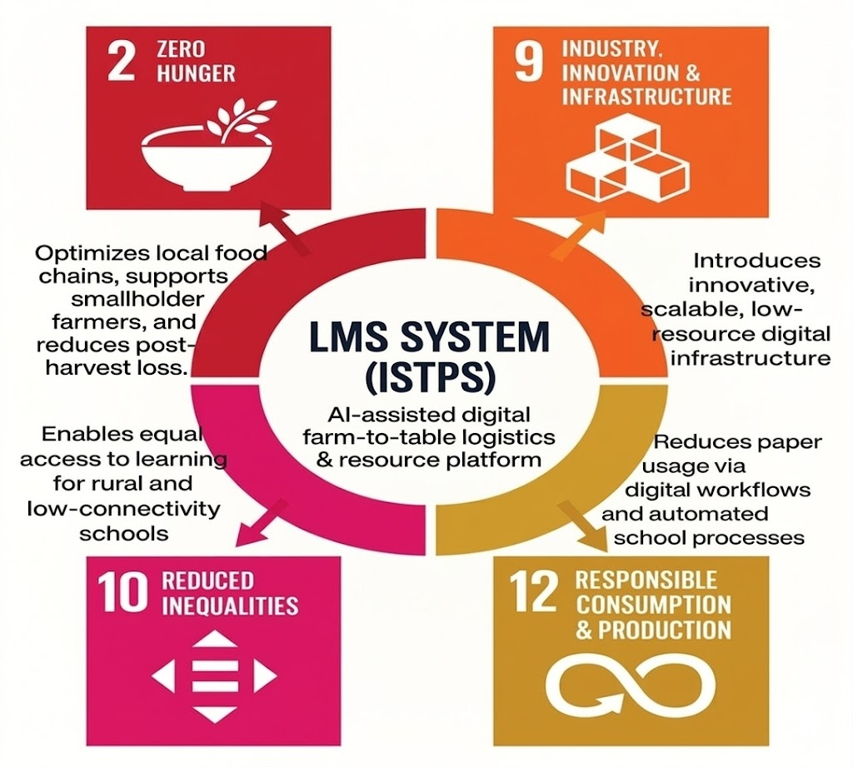

Fig 1.1 SDG Goals

Overview of Project Report
The present report presents an elaborate description of the process of planning, designing, developing and testing the Interactive Software Tool of Primary School Students.
The chapters are organized in the following way:
Chapter 1 presents the background, goals, and alignment with SDGs.
Chapter 2: This chapter provides a literature review of related educational technologies.
Chapter 3 describes how the system design and development is approached.
Chapter 4: Chapter 4 talks about project management, schedule, risk, and budget planning.
Chapter 5 is devoted to the analysis and design of the system, diagrams and models.

Chapter 6 expounds on the details of hardware, software and implementation.
Chapter 7 offers the results of evaluation and tests.
Chapter 8 brings to focus the social, legal and ethical of the project.
Chapter 9: The final chapter of the report presents conclusion and improvements to be made in future.

CHAPTER 2
Literature Review

Literature review is a critique of past studies and research on the area of study. The areas of interest in this project are the AI-based crop recommendation systems, crop disease detection using deep learning, and smart agriculture platforms. The review contains scientific articles, technological systems, and smart agricultural systems that utilize machine learning, deep learning, and data-driven analytics to enhance the productivity of farming. This review is aimed at getting to know existing solutions, their shortcomings and how the proposed AI-Based Crop Recommendation to Farmers system offers a more integrated and accessible option to farmers.

Evolution of Smart Agriculture Systems

The use of digital technologies in agriculture is rapidly growing in recent years, with farmers trying to find effective ways to enhance productivity and resource utilization. Hasan et al. (2022) argue that the combination of Artificial Intelligence (AI), Internet of Things (IoT), and data analytics has turned the traditional agriculture into precision farming as it allows data-driven decision-making. These technologies assist farmers in keeping track of the conditions of the soil, the weather, and the health of crops more precisely.

On the same note, Basin et al. (2023) noted that machine learning algorithms can be used to process vast amounts of agricultural data to forecast crop production and provide recommendations on proper farming techniques. Farming platforms based on predictive analytics give the farmer an opportunity to identify the most suitable crop depending on the environment and soil conditions.

Although these developments have been made, most of the current agricultural systems need specially designed hardware or IoT devices, which may be expensive and challenging to implement on small-scale farmers. In the proposed AI-Based Crop Recommendation System, this limitation is mitigated by offering a web-based solution that enables farmers to enter soil parameters and be given crop recommendations without need of expensive hardware infrastructure.

Crop Recommendation Systems

Another key area of research in precision agriculture has taken the form of crop recommendation systems. These systems examine soil nutrients, environmental parameters, and climatic conditions to establish the most appropriate crop to be cultivated. A study by Rahman (2024) proposed an AIoT-based hydroponic system to collect environmental data and suggest crops with the help of machine learning models.

On the same note, a number of studies have shown that machine learning algorithms like decision trees, regression models and neural networks are useful in predicting crop suitability with respect to the nutrient content in the soil in terms of nitrogen, phosphorus, potassium and pH levels.

Nevertheless, most of these systems would be research-based or demand elaborate sensor networks, and thus are less affordable to farmers in the rural setting. The system presented proposes to simplify this task and enable farmers to manually input soil parameters and get crop advice based on artificial intelligence via a simple web interface. This will be a way of making it accessible and easy to use to farmers who might not be accessing the sophisticated agricultural technology.

Crop Disease Detection Using Deep Learning

Agricultural losses in the world are also caused by crop diseases. Plant diseases can be treated at an early stage that can greatly save on crop losses and enhance production. Recent studies have indicated that deep learning models, specifically Convolutional Neural Networks (CNNs) are very efficient in detecting plant diseases by analyzing images.

Bezabh (2024) trained a mango disease ensemble CNN model, showing excellent effectiveness in the detection of plant diseases using leaf images. Likewise, Javidan (2024) wrote about the possibility of using feature engineering and image processing to enhance disease detection models despite small datasets.

Despite the positive outcomes of these systems, a significant number of them are only intended to work in the laboratory, and are not easily handled by a farmer. The suggested system incorporates a web-based image upload tool by which farmers will be able to upload crop photos to identify diseases with trained deep learning models. This offers a feasible and convenient solution to farmers to diagnose crop diseases at an early stage.

Integration of Chatbots in Education

AI has emerged as the technology in contemporary farming by making predictive analytics, automation, and intelligent decisions. Ghazal (2024) states that the usage of AI-based computer vision and machine learning methods is common in areas like crop monitoring, disease detection, and yield prediction.

Artificial intelligence systems can process vast amounts of agricultural data to see trends and come up with insights, which are used by farmers to maximize their use of resources like water, fertilizers, and pesticides. This aids in enhancing crop production with a lesser environmental impact.

Nevertheless, there are numerous AI-based agricultural systems that need technical skills and complicated implementation, and this aspect can restrict their use among other farmers. The given system is aimed at offering a user-friendly, intuitive interface enabling farmers to receive AI-based suggestions without having to possess technical skills.

User Interface and Accessibility in Agricultural Systems
The availability and easy accessibility to the technology by farmers is one of the key issues in the implementation of smart agriculture systems. The studies of the adoption of agricultural technology indicate that easy-to-use interfaces and language familiarity should be considered to enhance adoption among rural farmers.
Most of the current applications in agriculture are developed mostly in English, and this can be a hindrance to the regional language-speaking farmers. The proposed system will overcome this problem by ensuring that it has a multi-language user interface that will support English, Kannada, Tamil, and Hindi. This will allow the farmers with diverse language to make use of the platform easily.
Besides, the web-based design will be accessible on different devices including smartphones, tablets, and desktop computers. The system will allow more people to use advanced agricultural technologies in their daily farming processes by integrating an easy-to-use interface with the ability to support multiple languages.

Summary of Literature Findings
As shown in the Table 2.6.1, the literature review has pointed out a number of important shortcomings of educational software systems,
Table 2.6.1 : Summary of Literature Findings

Observed Limitation | Existing Systems | How This Project Solves It
Lack of a unified agricultural support platform | Separate tools for crop recommendation, disease detection, and fertilizer guidance | Single platform with all features
High dependency on specialized hardware or IoT infrastructure | IoT-based smart farming systems requiring sensors and expensive equipment | Manual soil data input
Limited accessibility due to language barriers | Many agricultural advisory apps available only in English | Multi-language support
Complex interfaces not suitable for farmers with limited technical knowledge | Research-based agricultural systems with complicated dashboards | Simple user-friendly interface
Lack of early disease identification tools for farmers | Manual inspection or expert consultation for disease detection | AI-based disease detection

Chapter 3 Methodology

This section explains the project approach, system planning, and design that was applied in developing the AI-Based Crop Recommendation for Farmers system. The methodology provides that the system should be reliable, user friendly by the farmers and can be scaled in future to improve the system. It describes the process of implementing a decision-support platform in agriculture by collecting data, developing the model, integrating the system and conducting testing to create an efficient system.

3.1 Research and Requirement Gathering

The initial phase of the methodology was to identify and analyze the needs of the key stakeholders, among them are farmers, agricultural experts and system developers.

The main aims of this phase were:

• Determining the farming requirements of the farmers such as crop advice, disease diagnosis, and fertilizer advice.

Strategies to address these constraints include; identifying limitations like lack of technical expertise, language, and accessibility to modern farming equipment.

• Knowledge of the difficulties encountered by farmers in choosing appropriate crops, early detection of plant diseases and the management of nutrients in the soil.

The result of this stage was a definite list of non-functional and functional requirements which was considered as the basis of designing and implementing the AI-based system.

Planning and Strategy
Once the requirements were gathered, a development strategy was developed to be used to implement the system.
1. User-Centered Design: The user interface was made simple and easy to use by ensuring that the platform can be easily used by farmers who have little technical knowledge.
2. Integrated Agricultural Tools: This system incorporates crop recommendation, crop disease detection, and fertilizer calculation in one web based system.
3. Modular Development: The system was separated into modules which included crop recommendation, disease detection, fertilizer calculation, and multi-lingual user interface.
4. Availability Web Platform: The web platform selected was browser-based to ensure that farmers can access the system via smartphones, tablet, or computers.
5. Multi-Language Support: The portal can accommodate English, Kannada, Tamil, and Hindi, thus making it accessible to farmers in various areas.
A combined Waterfall and Agile development approach was used for building the system.
Elements of waterfall: The elements of the requirement analysis, planning, and system design were organized in a linear manner to have clear milestones on the project.
Agile Elements: Model development and interface design was done using iterative development and testing in order to enable constant improvement using feedback.
This balanced method was both a safe way to plan but gave the opportunity to enhance AI models and system usability.

System Design and Module Planning
The system architecture was broken down into four large modules after the planning phase.
• User Authentication Module: Enables farmers to log in to the platform to be able to access it.
Usage: Crop Recommendation Module is an example of machine learning that can provide recommendations on which crops to grow depending on soil parameters including Nitrogen (N), Phosphorus (P), Potassium (K), pH, temperature, and humidity.
Crop Disease Detection Module: Applies the models of deep learning to analyze the images uploaded by farmers and identify the plant diseases.
Fertilizer Calculator Module: The module gives recommendations on the use of fertilizers on the soil depending on the soil nutrient content so that the soil is maintained in a suitable condition and therefore yield better produce.
Each of the modules was to be developed separately and connected on a single web platform to work together.

Testing and Integration
To provide reliability to the system, various methods of testing were used throughout the development process.
• Functional Testing:
Ensured that all modules (crop recommendation, disease detection and fertilizer calculator) are functioning as they were intended.
• Usability Testing:
Concentrated on making the interface easy and comprehensible to farmers.
• Model Validation:
Accuracy of machine learning and deep learning models were tested on agricultural data.
• Iterative Feedback:
Processing of the feedback in the form of improvements was made in testing to improve the performance and usability of the system.
The testing procedure made sure that the end system offers reliable advice and user-friendly interface.

Documentation and Maintenance Strategy

The long-term sustainability, usability, and scalability of the AI-Based Crop Recommendation for Farmers system require a well-designed documentation and maintenance plan. The site combines features of crop recommendation, crop disease detection and calculation of fertilizers into a web based interface that is user friendly to farmers. This section explains the approach that will be used to ensure technical clarity, future development, and a stable user experience among farmers and system administrators.

Documentation Strategy

A good documentation plan should be adopted to ensure there is clarity on the architecture of the system, features and the possibility of future development. When appropriate documentation is carried out, developers, administrators and subsequent researchers will find it easy to comprehend the structure and how the system works. The documentation also aids in keeping the systems transparent and enhances the ability to easily upgrade or add more system capabilities.

Documentation

General text: System documentation will be a detailed technical description of the system architecture, components, and data flow:

• Architecture Documentation:

An extensive record of the system architecture is kept. The frontend web application, which is applied by farmers, the machine learning models, which do crop recommendation and disease detection, and the data processing components are described in the documentation. They contain block diagrams and flowcharts, which show how the modules can interact with each other, including soil parameter input, crop prediction, disease detection, and fertilizer calculation.

• Model Documentation:

The machine learning and deep learning models are documented in the system. It contains details of the algorithms applied to recommend crops, how the models are trained, details of the data set, measurement of evaluation, and accuracy of prediction.

• Dataset Documentation:

Data on training and testing datasets of the models are stored. This has information on soil parameter datasets (crop prediction), image datasets (crop disease detection).

• User Interface Documentation:

Screens, flows, input forms and result dashboards are captured on screenshots or wireframes. This will guarantee the new developers on the future how users will relate with the platform.

User Documentation
Farmers are the main users of the system as they will be the ones who will be creating the user documentation. The documentation is directed towards simplicity and clarity as many users might have limited technical experience.
• User Manuals
Detailed information on how farmers can log in to the system, how to input soil parameters, including nitrogen, phosphorus, potassium, pH, temperature, and humidity and upload crop images to detect diseases and receive fertilizer recommendations.
• Quick Start Guide
A simplified user guide that enables users to quickly learn the most important functions of the system. The guide is written in simple terms and with simple instructions so that farmers can easily access the features of the system.
• Language Support Guide
Guidelines on how the farmers would change the platform interface to one of the supported languages like English, Kannada, Tamil and Hindi so that it would be easier to access.
• FAQ Section
The FAQ section will cover the most frequent problems like inputting the wrong parameters, uploading pictures, or trouble with simple system use.

Developer Documentation

The developer documentation will assist in maintaining the system and future development of the system since it will give specific technical direction:
Codebase Documentation The codebase is properly documented by comments, separated folders and description of modules that perform crop prediction, disease detection and calculation of fertilizers.
• Installation and deployment instructions: This is a guide to installing all software libraries that are needed, setting up development environments, loading data, and running the system locally or on a server.
• Version Control Notes: Git is employed to monitor code changes and a record of system changes. The information on branching strategies and release versions is documented to provide effective cooperation between developers.

Maintenance Strategy
As the platform is destined to guide farmers to make regular agricultural decisions, it has to be maintained continuously to guarantee the reliability of the system, its performance, and its flexibility to address the needs of the future.
1. Corrective maintenance
Corrective Maintenance aims at discovering and addressing problems identified during deploying a system:
• Correcting a wrong crop prediction output.
• Fixing issues in uploading images or disease detection.
• Fixing authentication or login problems.
• Fixing broken interface components or navigation problems.
2. Adaptive Maintenance
Adaptive maintenance entails the process of updating the system to suit the changing agricultural needs and technological advances:
• Additional support of new crops and soil parameter datasets.
• Retraining machine learning models using better training data.
• New classrooms or adjustment to the academic year.
• Language support to other regional languages.

3. Perfective Maintenance
Perfective maintenance aims at enhancing performance, usability and accuracy of the system even after the initial system design:
• Training machine learning models to achieve higher prediction accuracy.
• Enhancement of user interface to make it easy to input data to farmers.
• Enhancing visualization of recommendations and results.
• New features: crop recommendations based on the weather, or pest warnings.
4. Preventive Maintenance
Preventive maintenance guarantees stability and reliability of the system in the long run:
• Making new updates to machine learning libraries and dependencies.
• Training machine learning dependencies and libraries.
• Carrying out regular data and model backups.
• Eliminating old information or unused system files.
• Carrying out security inspections to avoid vulnerabilities.
5. Maintenance Documentation
System documentation is a living document, which is continuously updated with the project.
• Documentation of model is updated.
• User guides and interface screen shots are updated.
• Updates in datasets or models are recorded.
This provides traceability in the long run, and can be further extended by developers or research teams later to provide a broader system.

Tools and Techniques Overview

The AI-Based Crop Recommendation for Farmers system was created using a systematic and rigorous approach. The development process was organized with several tools and techniques to be implemented easily.

Planning and Design Tools

Flowcharts: These are diagrams that are used to show the processes of the system like crop recommendation process, disease detection process and the process of calculating the fertilizers.

Block Diagram: This diagram is used to show the general structure of the system, data input, machine learning processing, and output generation.

System Mockups: Designs that were created to make the web interface layout visible and to make sure that the final design would be simple and easy to use by farmers.

Version Control and Iterative Development
• Version Control (Git): Git was employed to follow the change of the code and to handle the collaborative development. It assisted in ensuring the stability of the systems and providing the possibility of continuous improvements.
  - Iterative Development: The system was constructed in steps whereby a module crop recommendation and disease detection and fertilizer calculation was first implemented, tested and improved before the final integration.

Feedback – Driven Refinement
• Simulated User Testing: Test users were involved in testing the platform to point out usability issues and how it could be improved.
  - Feedback Cycle: The cycle of feedback was continuous, with improvement made on the basis of user feedback to increase accuracy, accessibility and user experience.

Systematic Transparent and Adaptive Approach
- The development process was organized in a systematic way to make sure that all the steps of the project were well defined and implemented.
- Progress was also checked frequently to make sure that system objectives were met.

Chapter 4
Project Management

The AI-Based Crop Recommendation to Farmers system was developed with the role of effective project management. Effective planning, coordination and supervision ensured that project objectives were met in the planned timeline and that the systems were of quality and reliable. It involved planning of tasks, allocation of resources, development of models, system integration and testing. All the stages were arranged to achieve the success of crop recommendation, disease detection, calculation of fertilizer, and multilingual support. Close monitoring and assessment of the system made it reliable, efficient, and affordable to the farmers.

Project Timeline and Phases
The project spanned a total of sixteen weeks and was divided into separate phases to allow for orderly completion. Refer to Table 4.1 for the detailed breakdown.

Project Phases:
Milestone Highlights
• Week 2: System requirements are finalized and identification of datasets needed to perform crop recommendation and disease detection is completed.
• Week 4: System architecture design, user interface mockups.
• Week 8: Building prototype modules of crop recommendation and fertilizer calculator.
• Week 10: Crop disease detection model integration and multilingual interface support.
• Week 13: Iterative testing, system optimization and bug fixing to enhance system reliability.
• Week 16 : Final system deployment and preparation for project demonstration.
The systematic schedule helped to track the development of the project effectively and make sure that every stage of development was done in a systematic manner.

Risk Analysis and Management
As indicated in Table 4.2 , Risk management is one of the most important aspects of project management. In this project, the risks were evaluated in terms of their probability, impact and potential mitigation.
Table 4.1 Project Phases

Phase | Duration  (in weeks) | Key Activities | Milestone/Deliverables
Requirement Analysis | 1-2 | Identifying farmer needs, studying crop datasets, analyzing soil parameters and agricultural problems | Requirement Specification  Document
System Design | 3-4 | Designing system architecture, UI layout, model workflow, and database structure | System Design Document
Development (Core Modules) | 5-8 | Implementation of crop recommendation model, fertilizer calculator, user login system, and multilingual interface | Working Prototype of Admin & Student Portals
Chatbot Development | 9-10 | Development and integration of deep learning model for crop disease detection using image input | Fully Functional Chatbot
Testing & Iteration | 11-13 | Unit testing, integration testing, model accuracy and  system testing | Tested & Refined Module
Deployment  Preparation | 14 | Dataset validation, system optimization, interface responsiveness testing | Ready-to-Deploy System
Final Evaluation & Documentation | 15-16 | Preparing project report, documentation, and system demonstration setup | Complete Project Report & Demo

Table 4.2 Identified Risks

Risk | Impact | Likelihood | Mitigation Strategy
Incorrect crop prediction due to poor data quality | High | Medium | Use verified agricultural datasets and perform model validation
Inaccurate disease detection results | High | Medium | Improve model training with larger  image datasets and continuous testing
Integration issues between modules | Medium | Medium | Continuous integration testing after each development phase
Interface complexity for farmers | Medium | Low | Design a simple UI and perform usability testing
Time overrun | Medium | Low | Follow project timeline and conduct regular progress reviews

Risk Mitigation Strategies

• Proactive Testing: Unit testing and integration testing were done to the extent to make sure that modules like crop recommendation, disease detection, and calculation of fertilizers worked properly.

• Iterative Feedback: Test user and simulated farmer feedback was used to diagnose usability problems and enhance the accuracy of the system.

• Structured Backups: Backups of datasets, trained models and source code were periodically done to avoid data loss.

• Monitoring and Reporting: Progress reviews weekly assisted in the detection of the possible problems at an early stage and in keeping the project on track.

Time and resource management enabled the project to go through each milestone in a seamless manner.

Resource Allocation and Team Roles

Although the project was mostly designed on a one-on-one basis, to ensure the project was successful, time, tools, and technical resources had to be carefully planned.

Time Allocation: Tasks were split into weekly goals to provide a systematic development of the tasks that included data collection, model development, system integration, and testing.

Human Resource Management: The following responsibilities were involved:

Project Planning and Design: Requirement analysis, system architecture design, flowcharts and user interface planning.

Development Programs: Crop recommendation model, disease detection model, fertilizer calculator, and multilingual interface.

Testing & Feedback: Checking the model, system testing, tracking of bugs and refining features with feedback.

Documentation: Writing of project reports, system diagrams, technical documentation and presentation materials.

Quality Assurance
- Quality assurance practices were also integrated in the project to provide reliability, accuracy and usability of the system.
- Module Testing: Each of the individual modules like crop recommendation, disease detection and fertilizer calculation were individually tested in order to ensure that they worked.
        - Integration Testing: Various modules were combined and tested as a unit to make sure that there was a good interaction and the system worked well.
- Usability Testing: Test users were used to assess the system interface to make sure that farmers were able to input soil data, crop images and understand recommendations easily.
- Bug Tracking: The errors and issues were identified and corrected via testing and refinement.
- Performance Testing: The system underwent testing to establish high response speed, correct predictions, and easy performance among various machines and web browsers.
Chapter 5 Analysis and Design

Requirements

Prior to the development and design of the AI-Based Crop Recommendation for Farmers system, an extensive system needs analysis was carried out. The primary aim of this step was to determine the most crucial functional and non-functional requirements of the system taking into consideration user requirements and technical constraints. These needs were obtained by researching on smart agriculture systems, looking at agricultural data, and realizing the difficulties of farmers in the selection of crops, the detection of diseases, and the management of soil nutrients. The analysis assisted in setting the system characteristics like crop recommendation, crop disease detection, calculation of fertilizers, and multilingual support. The determined requirements formed the basis of the design of the system architecture and effective implementation of the platform.

Functional Requirements

Functional requirements explain the particular functions and features that the system has to execute in order to realize its goals. The AI-Based Crop Recommendation to Farmers system aims to assist farmers in a way that is intelligent to offer farming recommendations and tools.

1. User Authentication and Access Control.

• The farmers should be capable of logging in safely to the platform.

• The system must offer a secure authentication system to secure user data.

2. Crop Recommendation System

• Farmers are able to enter the parameters of soil; Nitrogen (N), Phosphorus (P), Potassium (K), pH level, temperature and humidity.

• These inputs are analyzed by the machine learning model to suggest appropriate crops to be grown.

3. Crop Disease Detection

• Farmers can upload images of crop leaves through the platform.

• The deep learning model is used to analyze the uploaded images and come up with recommendations of the potential plant diseases.

4. Fertilizer Recommendation

• The system also offers fertilizer recommendations based on the values of nutrients in the soil to enhance the fertility of the soil.

• The system assists farmers to keep the right balance of nutrients to achieve high crop productivity.

5. Multi-Language User Interface

o The system gives the users a choice of interface in English, Kannada, Tamil, and Hindi.

o This makes it more accessible to farmers in other regions.

6. Data processing and input.

o Farmers will be able to enter soil parameters via a simple form interface.

o The system takes the input data and uses machine learning models to give recommendations.

7. Dashboard and Results Display.

o The system has a well-defined dashboard with crop recommendations, illnesses detected, and the recommendations made on fertilizers.

o The results are presented in a basic and easily comprehensible format to farmers.

8. Dashboard and Notifications

o Real-time dashboard.

o Outputs notifications.

1.1.2 Non-Functional Requirements
Non-functional requirements are quality attributes of the system that include usability, performance, security, and reliability. These specifications guarantee that the system is efficient and offers a good user experience.
1. Usability
• The interface should be user-friendly and straightforward to the farmers with poor technical skills.

• The layout must have easily readable text, and simple navigation with clear input forms.
2. Performance
• The system must be able to produce crop recommendations and disease detection results in several seconds.
• The system must be able to respond quickly when used in normal conditions.
3. Scalability
The system must be able to accommodate more crops, data sets and new features in future.

• The architecture must be able to integrate with the mobile applications or data sources based on IoT.
4. Security
• User accounts need to be securely logged in.
• Handling of sensitive user data should be done in a secure manner to avoid unauthorized access.
5. Maintainability
The system must be designed according to a modular architecture to be able to update modules like crop recommendation or disease detection.
Proper documentation must be kept in case of future upgrades.
6. Accessibility
Further, the site must be available using desktops and mobile gadgets.
Multi-language support is an aspect that will make sure that the system is simple to use by farmers of varying linguistic backgrounds.

Block Diagram
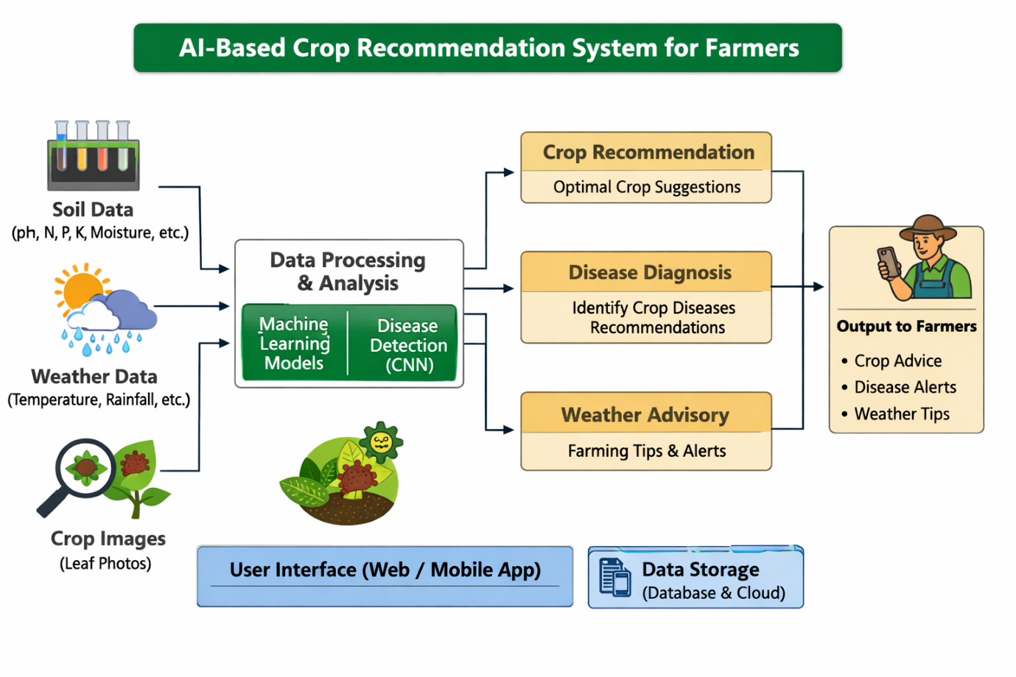
    - As shown in Figure 5.2.1, shows a block diagram that represents the different levels of hierarchy of the Presidency Portal. These include the Frontend Layer, Application Logic Layer as well as Data Storage Layer. In the case of the frontend, the functionality deals with the interactions of the user.
and the admins and students. In the application layer, we have the core logic functionalities that include, among others, the different.

Fig 5.2.1 Block Diagram

System Flow Diagram
Figure 5.3.1 System flow chart System Flow Chart is a flow chart that illustrates the order of activities carried out by student logging to AI Based Crop Recommendation System to Farmers. The system starts with the user login and thereafter, the farmer is redirected to the main service modules of the platform.
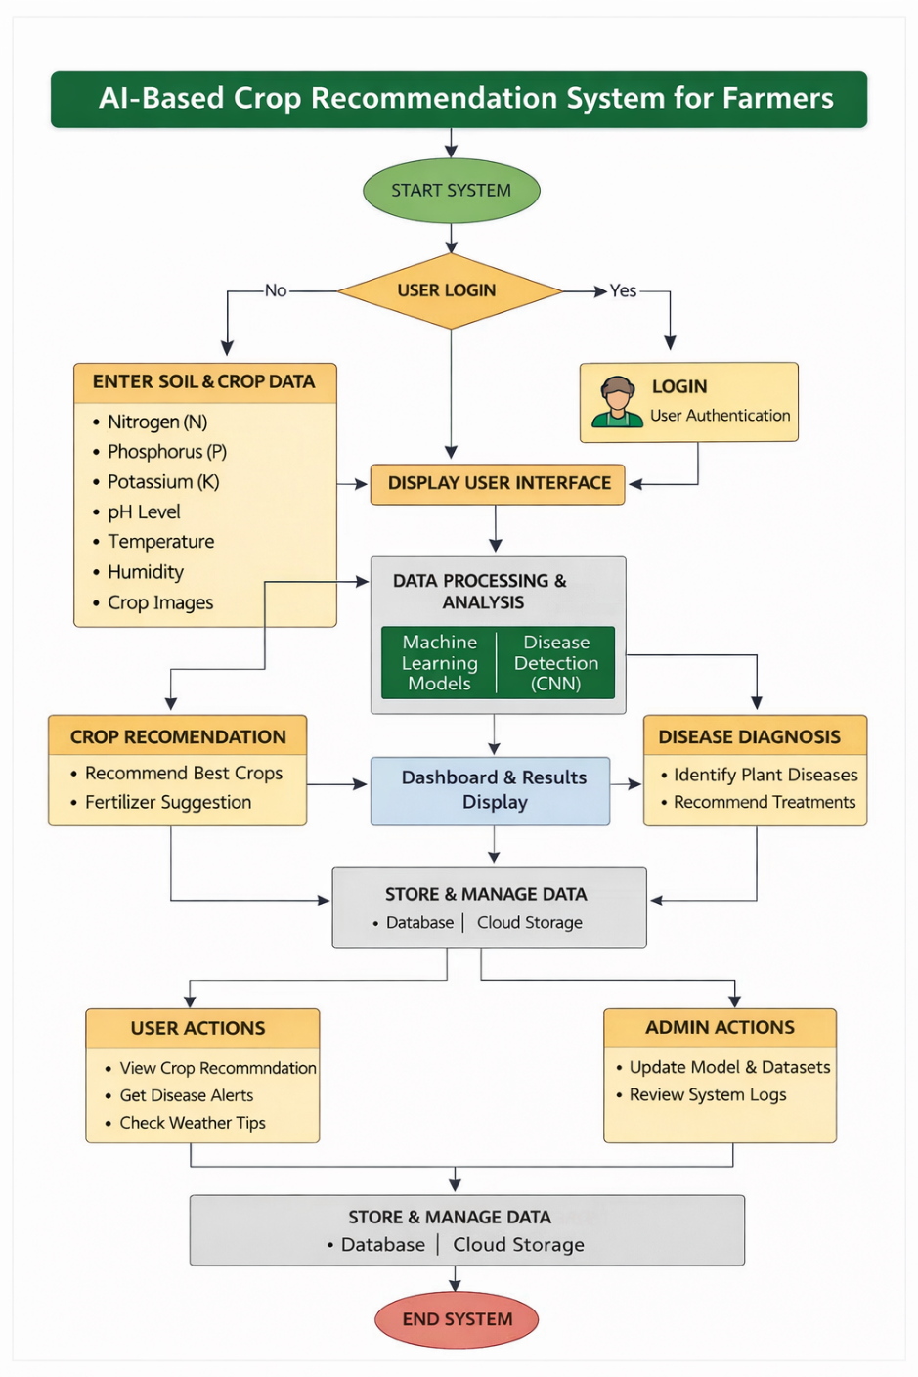

Fig 5.3.1 System Flow Chart

Designing Units
The system is split into functional units, which address various activities of the AI-Based Crop Recommendation for Farmers platform. This is a scalable, maintainable, and efficient design; this is because it is a modular design (see Fig 5.4.1 to see a visual image of it).
1. Authentication and the User management unit.
• Deals with user authentication of farmers.

• Provides secure session management and authentication.

• Permanently stores user information to facilitate easy access to the features of the system.

2. Crop Recommendation Unit
• Enables farmers to key in soil parameters that include Nitrogen (N), Phosphorus (P), Potassium (K), pH, temperature, and humidity.

• Uses machine learning models to analyze input data.

• Offers appropriate crop suggestions that are dependent on the environment and soil.

3. Crop Disease Detection Unit.
• Enables farmers to upload crop leaf images.

• Relies on deep learning ( CNN ) models to identify plant diseases.
• Shows the name of the disease and recommended remedies.

4. Fertilizer Recommendation Unit
• Computes the needs of fertilizers using the nutrient values of soil.

• Suggests appropriate nutrient composition to improve soil fertility.

• Helps farmers keep the use of fertilizers balanced.

5. Data Processing and Model Unit.
• Feeds on data with machine learning and deep learning models.
• Deals with prediction of crops and diseases.
• Enforces proper and effective data analysis.

6. Multi-Language Support Unit
• Gives language switching options such as English, Kannada, Tamil and Hindi.
• Enhances increased accessibility by the farmers in various regions.
• Shows outputs of the system in the chosen language.

7. Dashboard and Results Unit.
• Shows fertilizer recommendations, disease identification, and displays crop recommendations.
• Offers easy and straightforward interface that farmers can comprehend.
• Arranges the outputs in a readable format.
8. User Interface and Navigation Unit.
• Offers a friendly and easy-to-use interface to farmers.
• Has basic input forms and easy navigation within modules.
• Ensures that it is responsive to both mobile and desktop use.

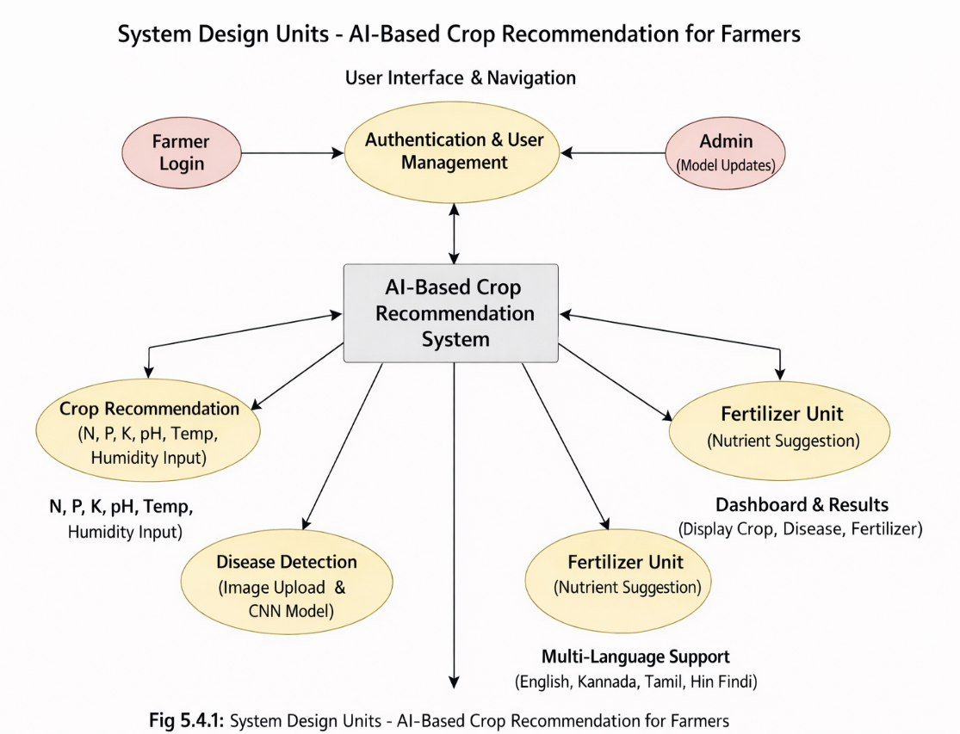
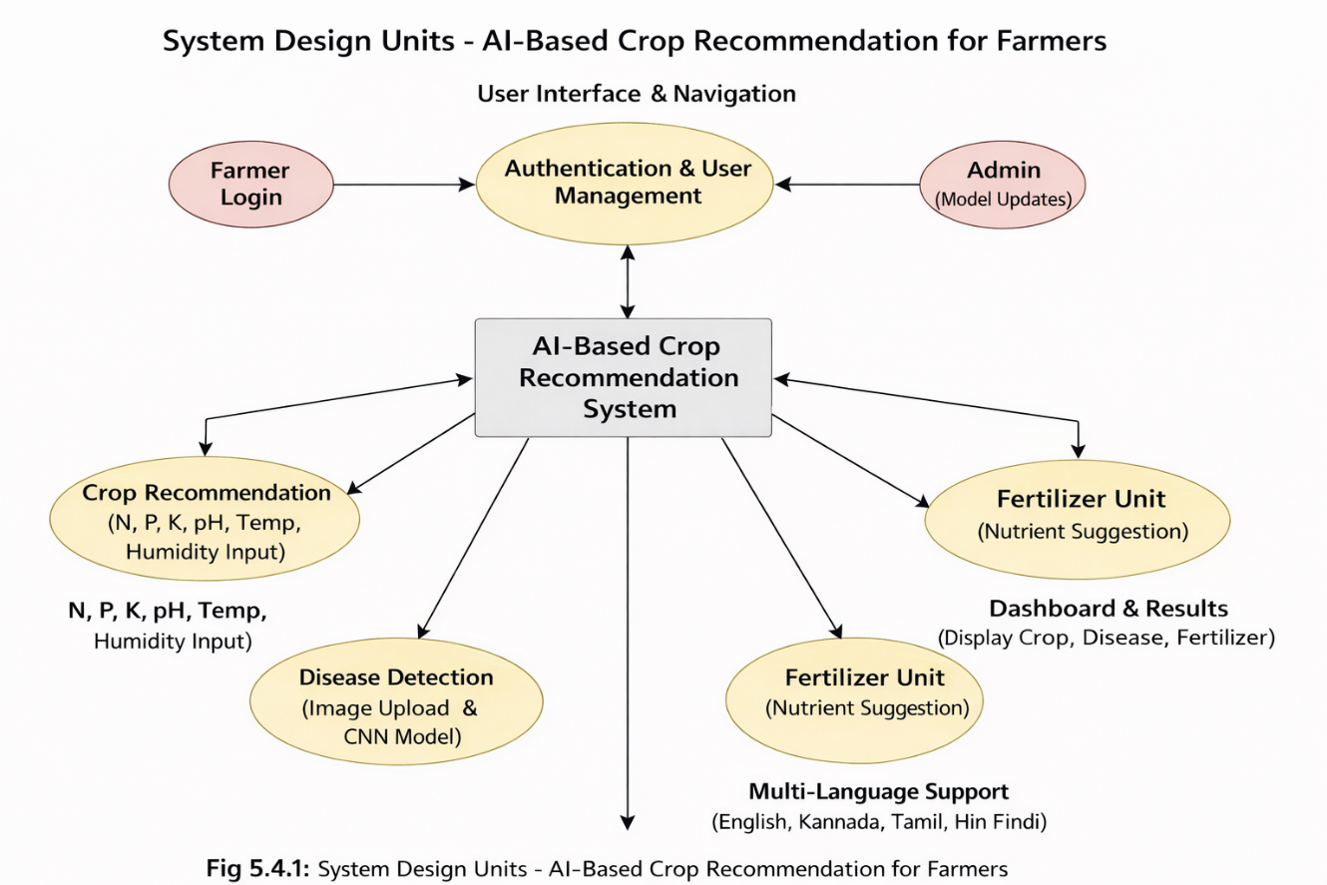
Fig 5.4.1 Designing Units

Standards
Following standard practices ensures that the AI-Based Crop Recommendation for Farmers system is reliable, secure, scalable, and user-friendly. These standards cover software development, data handling, security, user interface design, and testing processes, making the system suitable for real-world agricultural use.

Software Development Standards

        - The system follows a modular architecture, ensuring separation between data processing (models), application logic, and user interface.
        - Standard programming practices using Python for AI models and web technologies (HTML, CSS, JavaScript) ensure maintainability and scalability.
        - The web application is designed to be cross-browser compatible and follows standard web guidelines for responsiveness.

Data Management Standards
        - Structured datasets are used for training machine learning and deep learning models to ensure data accuracy and consistency.
        - Proper data handling techniques are applied to avoid redundancy and maintain data integrity.
        - Input validation ensures that only correct soil parameters and image data are processed by the system.

Security and Privacy Standards
        - The system follows standard security practices to prevent vulnerabilities such as invalid inputs and unauthorized access.
        - User credentials are handled securely using authentication mechanisms.

        - Data transmission and system interaction follow secure practices to protect user information.

User Interface and Accessibility Standards

        - The interface is designed to be simple, clear, and easy to use for farmers with minimal technical knowledge.
        - The system supports multiple languages (English, Kannada, Tamil, Hindi) to improve accessibility.
        - The application is responsive and works efficiently on desktops, tablets, and mobile devices.

Testing and Documentation Standards
        - Unit testing and integration testing are performed to ensure that all modules function correctly.

        - The system is tested for usability, performance, and accuracy of predictions.

        - Proper documentation, including user guides and technical details, is maintained to support future development and maintenance.

Domain Model Specification
The domain model for the AI-Based Crop Recommendation for Farmers system represents the key entities, their attributes, and relationships within the platform. It helps in understanding how different components of the system interact with each other and support overall functionality.

Objectives of Domain Modeling
The domain model functions:

- Represent the core functional areas of the system such as crop recommendation, disease detection, and fertilizer guidance.
- Identify key entities involved in the system and define their relationships.

- Specify attributes of each entity to support system operations and data processing.

Key Entities and Their Descriptions

The domain model consists of the following important entities:

User (Farmer)

  - Represents the primary user of the system.
  - The farmer interacts with the system to input soil data, upload images, and receive recommendations.
  - The farmer interacts with the system to input soil data, upload images, and receive recommendations.

Soil Data

  - Represents the input parameters provided by the farmer.
  - Used for crop recommendation and fertilizer calculation.

Attributes: soil_id, nitrogen (N), phosphorus (P), potassium (K), pH, temperature, humidity
- Crop Recommendation
  - Represents the output generated by the machine learning model.
  - Suggests suitable crops based on soil and environmental data.

Attributes: recommendation_id, soil_id, recommended_crop, confidence_score.

- Disease Detection
  - Represents the disease prediction results from uploaded crop images.
  - Uses deep learning models to identify plant diseases.
  - Attributes: disease_id, image_path, detected_disease, accuracy, suggested_remedy.

- Fertilizer Recommendation
  - Provides fertilizer suggestions based on soil nutrient values.
  - Helps maintain soil fertility and improve crop yield.

Attributes: fertilizer_id, soil_id, recommended_nutrients, quantity.

- Model (AI/ML Model)
  - Represents machine learning and deep learning models used in the system.
  - Responsible for crop prediction and disease detection.

Attributes: model_id, model_type, accuracy, training_data.
- System Dashboard
  - Displays results to the farmer in a user-friendly format.
  - Shows crop recommendations, detected diseases, and fertilizer suggestions.
  - Attributes: dashboard_id, user_id, results_displayed.

Relationships Between Entities

The associations between these entities are seen below:
- User → Soil Data (One-to-Many): A user can input multiple soil data records.

- Soil Data → Crop Recommendation (One-to-One): Each soil data input generates one crop recommendation.
- Soil Data → Fertilizer Recommendation (One-to-One): Each soil data input produces a fertilizer recommendation.
- User → Disease Detection (One-to-Many): A user can upload multiple images for disease detection.

- Disease Detection → Model (Many-to-One): Multiple disease predictions are generated using a single trained model.
- Crop Recommendation → Model (Many-to-One): Multiple recommendations are generated using a trained ML model.
- Class → Assignment (One-Many): An assignment may belong to one or more classes.

- User → Dashboard (One-to-One): Each user has a personalized dashboard displaying results.

Communication Model

The communication model of the AI-Based Crop Recommendation for Farmers system describes how data flows between the user interface, processing components, and data storage/model layers. The system follows a client-server-like architecture, where the web-based frontend interacts with machine learning models and backend logic to process user inputs and generate outputs.

User Interaction Layer (Frontend)
  - Handles the user interface for farmers.
  - Allows users to input soil parameters (N, P, K, pH, temperature, humidity) and upload crop images
  - Displays outputs such as crop recommendations, disease detection results, and fertilizer suggestions.
  - Uses web technologies (HTML, CSS, JavaScript) to capture user inputs and present results.

Processing Layer (Logic Handling)
  - Contains the core logic for handling user requests and generating responses.
  - Machine learning models process soil data for crop recommendation.
  - Deep learning models (CNN) process images for disease detection.
  - Input validation and data formatting are handled before processing.

Data Storage Layer (XML-based Storage)
  - Stores datasets used for training machine learning and deep learning models.
  - Maintains user inputs temporarily during system interaction.
  - Handles retrieval and update of data required for predictions.
  - Acts as the backend layer supporting AI model execution.

Flow of Communication
The communication between different components of the system follows these steps:

      - User Request initiation: When a farmer enters soil data or uploads a crop image, the frontend captures the input and sends a request to the processing layer.
      - Data Processing: The system validates the input data and passes it to the appropriate machine learning or deep learning model.
      - Model Execution / Data Access: The model processes the input data and generates predictions such as crop recommendation, disease detection, or fertilizer suggestions.
      - Response Generation: The results generated by the models are formatted into a response and sent back to the frontend.
      - User Feedback: The frontend displays the results on the dashboard in a clear and user-friendly format.

This continuous flow of communication enables the system to function as an interactive and intelligent agricultural support platform.

5.7.4 Communication Characteristics
The communication model of the system has the following characteristics:

- Bidirectional Data Flow: Data flows between user input and system output continuously.

- Asynchronous Operations: Model execution and response generation occur efficiently without blocking user interaction.

- Event-driven Triggers: User actions such as submitting soil data or uploading images trigger system processing.

5.7.5 Communication Modes
The system supports the following communication modes:

User Interaction Mode (Farmer Mode):
  - Farmers interact with the system by entering soil parameters and uploading crop images.
  - The system processes inputs and provides crop recommendations, disease detection results, and fertilizer suggestions.

System Processing Mode (AI Model Mode):
  - The system internally processes user inputs using machine learning and deep learning models.
  - It retrieves relevant data, performs analysis, and generates accurate outputs.
Additionally, the system dashboard acts as an interactive interface, providing real-time responses and ensuring smooth communication between the user and the system logic.

Functional View
The functional view of the AI-Based Crop Recommendation for Farmers system illustrates how different modules and components work together to deliver intelligent agricultural services. It highlights the interaction between user inputs, processing mechanisms, and output generation to achieve the system’s objectives.

Overview
The system is designed as an integrated web-based platform that assists farmers in making informed agricultural decisions. It combines multiple functionalities such as crop recommendation, crop disease detection, fertilizer calculation, and multilingual support within a single interface. The system is designed as an integrated web-based platform that assists farmers in making informed agricultural decisions. It combines multiple functionalities such as crop recommendation, crop disease detection, fertilizer calculation, and multilingual support within a single interface.

Key Functional Modules

  - Crop Recommendation Module

    - Allows farmers to input soil parameters such as Nitrogen (N), Phosphorus (P), Potassium (K), pH, temperature, and humidity.
    - Uses machine learning algorithms to analyze the input data and recommend suitable crops.

Disease Detection Module

    - Enables farmers to upload images of crop leaves.
    - Helps farmers maintain proper nutrient balance for improved crop yield.

User Interface Module
    - Provides a simple and user-friendly dashboard for farmers.
    - Displays crop recommendations, disease detection results, and fertilizer suggestions clearly.

Functional Flow
  - Input Phase: The farmer enters soil parameters or uploads crop images through the web interface.
  - Processing Phase: The system processes the input data using machine learning and deep learning models to generate predictions.
  - Output Stage: The results, including crop recommendations, detected diseases, and fertilizer suggestions, are displayed on the dashboard in a clear and understandable format.

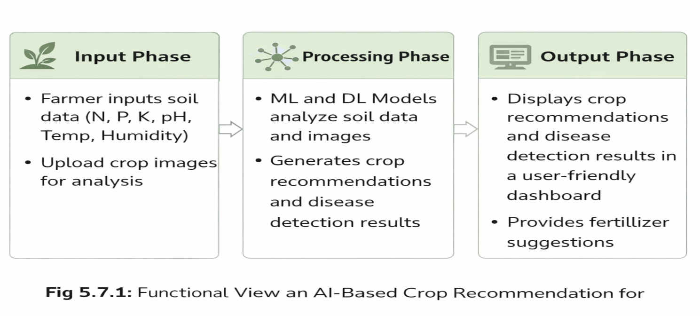
Fig 5.8.1 Functional View

Chapter 6 Hardware And Software
This chapter presents a detailed description of the hardware and software environment used for developing the AI-Based Crop Recommendation for Farmers system. It also explains the data representation and testing procedures used to verify system functionality, evaluate model performance, and ensure system reliability before deployment.

Hardware Requirements
As shown in the Table 6.1, Although the project is primarily a web-based application, certain hardware specifications were necessary for smooth development, machine learning model training, testing, and system execution.

Development Environment
Table 6.1.1 : Development Environment

Component | Specification | Purpose
Processor | Intel Core i5 or higher | Efficient model training, code execution, and multitasking
RAM | 8 GB or higher | Running machine learning models, development tools, and web servers
Storage | 10 MB free space | Storage for datasets, trained models, and project files
Graphics | Integrated or dedicated  GPU | Faster processing for deep learning image classification
Display | Full HD 1920x1080 | Accurate interface testing and responsive UI design
Peripherals | Keyboard, Mouse | Basic input devices for development and testing

  - Software Development Tools
The webdev technologies enable to develop a strong and scalable portal which is also user- friendly. These tools facilitated modular design, testing & seamless integration of interactive

features shown in Table fig 6.2.1

Frontend Tools
Table 6.2.1 Backend and AI Tools

Tool/Technology | Version/Details | Purpose
Python | 3.x | Core programming language for AI model development
Scikit-learn | Scikit-learn | Machine learning algorithms for crop recommendation
TensorFlow / Keras | Latest | Deep learning framework for crop disease detection
OpenCV | Latest | Data manipulation and preprocessing
Pandas | Latest | Accessible and reusable UI components

State Management & Data Handling
Table 6.2.2 : Web Development Tools

Tool/Technology | Purpose
HTML | Structure of the web interface
CSS | Styling and layout of the web application
Flask / Web Framework | Integration between AI models and frontend interface
JavaScript | Interactive web functionality

Form Handling and Validation
Table 6.2.3 : Data Processing Tools

Tool/Technology | Purpose
Jupyter Notebook | Model development and experimentation
Matplotlib / Seaborn | Data visualization and analysis
Kaggle Dataset | Agricultural dataset for crop recommendation and disease detection

6.2.4 Development Workflow
- Version Control: Git was used to manage source code versions and track project progress.
- Testing Tools: Python debugging tools and browser developer tools were used to test the application.
- Model Training Environment: Jupyter Notebook was used for dataset preprocessing, training machine learning models, and evaluating performance.

- Documentation Tools: Markdown editors and diagram tools were used to create system documentation, flowcharts, and architecture diagrams.

Data Representation
Simulation and testing are essential for verifying system functionality, validating predictions, and ensuring reliable interaction between system modules. The complete overview is shown in Table 6.3.1
The system processes two primary types of data:
• Soil parameter data used for crop recommendation
• Image data used for crop disease detection

Soil Data Representation

Farmers provide soil parameters such as nitrogen, phosphorus, potassium, pH level, temperature, and humidity to obtain crop recommendations

Table 6.3.1 : Representation Of Attendance Data

Nitrogen (N) | Phosphorus (P) | Potassium (K) | Temperature | Humidity | pH | Recommended Crop
90 | 43 | 43 | 20.8 | 82 | 6.5 | Rice
85 | 58 | 41 | 26.2 | 60 | 6.7 | Maize

Module Representation
- Crop Recommendation Module:
  - Accepts soil nutrient values from farmers.
  - Processes the data using machine learning algorithms.
  - Displays the most suitable crop recommendations.

Crop Disease Detection Module:
  - Farmers upload crop leaf images through the system.
  - The deep learning model analyzes the image to detect plant diseases.
  - The system provides the disease name and suggested remedies.

Fertilizer Recommendation Module:

Uses soil nutrient data to estimate the required fertilizer composition.

Provides recommendations to maintain soil fertility.

Multi-Language Interface

Allows users to switch between English, Kannada, Tamil, and Hindi.

Ensures accessibility for farmers from different regions.

Testing Workflows
      - Workflow 1 – Crop Recommendation: Farmer enters soil parameters → System processes data → Machine learning model predicts suitable crops → Result displayed on dashboard.
      - Workflow 2 - Assignment Start: Farmer enters soil parameters → System processes data → Machine learning model predicts suitable crops → Result displayed on dashboard.

        - verifies submission → Dashboard reflects completion.
      - Workflow 3 – Fertilizer Recommendation: Farmer inputs soil nutrient values → System calculates fertilizer requirement → Recommendation displayed to the user.
These workflows ensured the correctness of system interactions before deployment.

Performance Evaluation

System performance was evaluated through several tests
      - Verified crop prediction accuracy using agricultural datasets.
      - Tested disease detection accuracy with image datasets.

      - Evaluated system response time for generating recommendations.
      - Tested responsiveness of the web interface across different devices (desktop and mobile).
      - Ensured smooth operation of the multilingual interface for farmers.

Chapter 7 Evaluation and Results
Evaluation and testing were essential to ensure that the AI-Based Crop Recommendation for Farmers system met its functional, usability, and performance requirements. The purpose of this phase was to verify the reliability, accuracy, and user-friendliness of the developed system. Various testing procedures were carried out to examine the behavior of different modules such as crop recommendation, crop disease detection, fertilizer calculation, and the multilingual user interface. The results of these tests confirmed that the system performs efficiently and provides useful recommendations for farmers.

Test Points

The testing process focused on the following major areas to ensure that the system operates effectively and reliably:

User Authentication

- Verification of secure login functionality for farmers
- Validation of user access to system modules after authentication
- Display of recommended crops on the dashboard

Crop Recommendation Module

- Input validation for soil parameters such as Nitrogen (N), Phosphorus (P), Potassium (K), pH, temperature, and humidity
- Verification of machine learning model predictions
- Display of color-coded attendance indicators on dashboards

Crop Disease Detection Module
- Uploading crop leaf images for disease analysis
- Verification of correct disease detection using deep learning models
- Display of disease name and suggested remedies

Fertilizer Recommendation Module

- Calculation of fertilizer requirements based on soil nutrient values
- Verification of accurate nutrient recommendations
- Proper display of fertilizer suggestions to the farmer

Multi-Language Interface

- Switching between supported languages: English, Kannada, Tamil, and Hindi
- Verification that all interface elements are translated correctly
- Testing ease of navigation for users in different languages

Dashboard and Result Display

- Display of crop recommendations and disease detection results
- Clear presentation of information for easy understanding
- Verification of system responses after user input

User Interface & Responsiveness

- Navigation across modules
- Layout consistency on desktop, tablet, and mobile
- Visual feedback (toasts, progress bars, status indicators)

Test Plan
The test plan was designed to evaluate system performance through functional testing, usability testing, and model accuracy validation.

Testing Strategy
      - Functional Testing: Ensured that all modules including crop recommendation, disease detection, and fertilizer calculator operate correctly

      - Performance test: Measured system response time when processing user inputs and generating recommendations
      - Integration Testing: Verified that all modules work together seamlessly within the web platform.

Test Methodology
- Module Testing: Each module was tested individually to verify its functionality.

- End-to-End Workflow Testing: Complete workflows were tested, starting from entering soil data to receiving crop recommendations.
- Simulated User Interactions: Test users simulated farmer interactions such as uploading crop images and entering soil parameters.
- Data Persistent Testing: Input data was verified to ensure accurate processing by the machine learning models

Test Results
Observations produced from the testing of all modules are summarized and presented in tables below.

Crop Recommendation Module
Table 7.3.1 : Crop Recommendation Module

Test Case | Expected Result | Observed Result | Status
Enter soil parameter | System predicts suitable crop | Correct crop recommendation displayed | Pass
Invalid input handling | System validates input values | Input validation working correctly | Pass
Result display | Recommended crop shown clearly | Results displayed properly | Pass
Observation: The machine learning model successfully recommended crops based on soil parameters and environmental conditions.

Disease Detection Module
Table 7.3.2 : Disease Detection Module

Test Case | Expected Result | Observed Result | Status
Upload crop image | Image processed by model | Disease detected successfully | Pass
Disease identification | Correct disease predicted | Accurate results observed | Pass
Result display | Disease and remedy shown | Information displayed correctly | Pass
Observation: The deep learning model was able to detect crop diseases effectively from uploaded images

Fertilizer Recommendation Module
Table 7.3.3 : Fertilizer Recommendation Module

Test Case | Expected Result | Observed Result | Status
Enter soil nutrient values | Fertilizer recommendation generated | Correct nutrient suggestion displayed | Pass
Nutrient calculation | Balanced fertilizer values shown | Balanced fertilizer values shown | Pass
Display results | Clear fertilizer guidance | Displayed correctly | Pass
Observation: The fertilizer calculator provided accurate nutrient recommendations based on soil input data

Multi-Language Interface
.
Test Case | Expected Result | Observed Result | Status
Language switch | Interface language changes | Successfully switched languages | Pass
Content translation | All elements translated correctly | Verified for all languages | Pass
Navigation in different languages | Smooth interface usage | No errors found | Pass
Observation: The deep learning model was able to detect crop diseases effectively from uploaded images.

User Interface and Responsiveness
Table 7.3.4 : User Interface Module

Feature | Test Case | Observed Result | Status
Crop Recommendation Interface | Enter soil parameters and submit | Recommendation displayed clearly | Pass
Disease Detection Interface | Upload crop leaf image | Image processed and disease result shown | Pass
Language Switching | Change interface language | Successfully switched between English, Kannada, Tamil, Hindi | Pass
Navigation | Move between modules | Smooth navigation across all pages | Pass
Observation: The user interface was simple and responsive. Farmers could easily navigate between modules, enter soil data, upload images, and view results. The multilingual interface worked correctly without any usability issues.

Data Processing and Persistence
Table 7.3.5 : Data Persistence

Test Case | Expected Result | Observed Result | Status
Soil data input | System processes input values | Correct crop recommendation generated | Pass
Fertilizer calculation | Nutrient requirement calculated | Accurate fertilizer recommendation shown
Image upload | Image processed by model | Disease detection results displayed | Pass
Observation: The system successfully processed user inputs and generated accurate outputs for crop recommendation, disease detection, and fertilizer suggestions. Data processing remained consistent throughout testing.

User Interface and Responsiveness
      - The system interface was tested on multiple devices including desktops and mobile devices.

      - The layout remained consistent and responsive across different screen sizes.
      - Navigation between modules was smooth and user-friendly.

Insights and Analysis
Several important observations were obtained during the evaluation of the AI-Based Crop Recommendation for Farmers system:
- System Usability: The platform was easy to use, and farmers could easily input soil parameters and upload images.
- Prediction Accuracy: Machine learning and deep learning models produced reliable results for crop recommendation and disease detection.
- User Accessibility: The multi-language feature improved accessibility for farmers from different linguistic backgrounds.
- System Performance: The system generated recommendations quickly and maintained stable performance.
- Scalability: he modular design allows future integration of additional crops, datasets, and agricultural tools.
- Performance: Overall, the evaluation confirmed that the system effectively assists farmers in making better agricultural decisions and supports the adoption of smart farming technologies

Chapter 8
Social, Legal, Ethical, Sustainability, and Safety Aspects
The development of the AI-Based Crop Recommendation for Farmers system is not only focused on technological innovation but also considers its impact on society, legal compliance, ethical responsibility, sustainability, and system safety. This chapter discusses these aspects to ensure that the system supports responsible use of technology while benefiting farmers and the agricultural sector.

Social Aspects
The AI-Based Crop Recommendation for Farmers platform aims to improve agricultural productivity and support farmers in making better farming decisions. The system contributes positively to society by providing intelligent agricultural support and improving access to farming knowledge:

Improved Agricultural Accessibility
  - Provides farmers with easy access to crop recommendations based on soil parameters and environmental conditions.
  - Reduces dependency on agricultural experts by offering AI-driven decision support.

Increased Farmer Awareness
  - Helps farmers understand soil nutrients, fertilizer usage, and crop suitability.
  - Encourages the adoption of modern farming technologies and data-driven decision-making.

Support for Rural Farmers
  - Farmers in rural areas can access the platform through a simple web interface.
  - Multi-language support (English, Kannada, Tamil, and Hindi) helps farmers from different regions use the system comfortably.

Knowledge Sharing
  - The platform helps farmers learn about crop diseases and appropriate treatments.
  - Provides practical agricultural insights that improve crop productivity and reduce losses.
Observation: The system contributes to the modernization of agriculture by providing farmers with accessible digital tools that support better crop planning and farm management.

Legal Aspects
Developing an agricultural decision-support system requires consideration of legal regulations related to data usage, intellectual property, and digital services.

Data Privacy
  - The system collects minimal user data required for system functionality.
  - Sensitive information such as user credentials is handled securely to protect farmer data.

Intellectual Property (IP)
  - Machine learning models, datasets, and system algorithms are properly documented to ensure correct attribution.
  - Any external datasets or resources used in the system comply with licensing terms.

Regulatory Compliance
  - The platform follows standard guidelines for agricultural data processing and software development.
  - Future system expansions may comply with national digital agriculture policies and data protection regulations.

Ethical Aspects
Ethical implementation ensures that the system is fair, transparent, and beneficial to farmers.

Ethical considerations include:

Responsible Use of Data

      - Only necessary agricultural data such as soil parameters and crop images are used for analysis..
      - User data is not shared with third parties without permission.

Transparency
      - Farmers receive clear recommendations and results generated by the system.
      - The system provides understandable outputs to help farmers make informed decisions.

Fair Agricultural Guidance
      - The platform provides unbiased crop recommendations based on data analysis.
      - The system aims to support farmers without promoting specific commercial products or fertilizers.
Observation: Ethical considerations ensure trust and fairness while encouraging farmers to adopt AI-based agricultural tools.

Sustainability Aspects
Sustainability is about ensuring long-term usability, low resource usage and
environmentally-decent construction.

Resource Efficiency
      - Lightweight portal design reduces system requirements and energy consumption.
      - LocalStorage reduces the need for server communication, lowering electricity.

Future-Proof Design
      - Modular architecture allows future upgrades without major redevelopment.
      - Reusable components, TypeScript type safety, and documented code enhance maintainability.

Digital Literacy and Green Practices
      - Encourages digital learning rather than paper-based resources, reducing paper usage.
      - Provides an eco-friendly alternative for schools transitioning.
Observation : The portal promotes educational sustainability and responsible technology
use by focusing on efficiency and reusability.

Safety Aspects
Safety is an important factor when developing digital platforms, especially those used by farmers for decision-making.

System Security
      - Secure authentication mechanisms protect user accounts.
      - Input validation prevents incorrect or harmful data from affecting system functionality.

Secure Image Uploads
      - Crop images uploaded by farmers are processed safely without exposing sensitive system resources.
      - File validation prevents unauthorized file types from being uploaded.

Reliable Recommendations
      - Machine learning models are trained with verified agricultural datasets to ensure reliable results.
      - Testing and validation procedures help maintain system accuracy.

Chapter 9 Conclusion
The AI-Based Crop Recommendation for Farmers system is an intelligent and integrated web-based platform designed to support farmers in making better agricultural decisions. The system combines crop recommendation, crop disease detection, fertilizer calculation, and a multilingual user interface into a single accessible platform. By leveraging machine learning and deep learning techniques, the platform provides data-driven insights that help farmers choose suitable crops, detect plant diseases early, and manage soil nutrients efficiently.
Through this project, several objectives were achieved:
- Streamlined Administration: Farmers can input soil parameters such as Nitrogen (N), Phosphorus (P), Potassium (K), pH, temperature, and humidity to receive suitable crop recommendations using machine learning models.
- Early Disease Detection: The deep learning-based disease detection module enables farmers to upload crop images and identify plant diseases quickly, helping reduce crop damage.
- Fertilizer Guidance: The fertilizer calculator provides nutrient recommendations based on soil data, helping farmers maintain soil fertility and improve crop productivity.
- Improved Accessibility: The platform supports multiple languages including English, Kannada, Tamil, and Hindi, making the system accessible to farmers from different regions.
- Data-Driven Farming: he system encourages farmers to adopt modern agricultural practices based on data analysis rather than traditional guess-based methods.
- Overall, the AI-Based Crop Recommendation for Farmers platform demonstrates how artificial intelligence can be effectively applied in agriculture to improve productivity, support sustainable farming practices, and enhance decision-making for farmers.

References
- S. Ramesh and R. Thomas, “Machine learning approaches for crop recommendation based on soil and environmental parameters,” International Journal of Agricultural Informatics, vol. 11, no. 2, pp. 45–56, 2021.
- M. Hasan, M. Islam, and M. J. Sadeq, “Towards technological adaptation of advanced farming through AI, IoT, and robotics: A comprehensive overview,” Agricultural Technology Journal, vol. 15, no. 3, pp. 122–135, 2022.

- F. Z. Bassine, T. E. Epule, A. Kechchour, and A. Chehbouni, “Recent applications of machine learning, remote sensing, and IoT approaches in yield prediction: A critical review,” Agricultural Systems, vol. 205, pp. 103–114, 2023.
- S. Ghazal, “Computer vision in smart agriculture and precision farming: Techniques and applications,” Artificial Intelligence in Agriculture, vol. 6, no. 2, pp. 89–101, 2024.
- S. M. Javidan, “Feature engineering to identify plant diseases using image processing and artificial intelligence: A comprehensive review,” Journal of Plant Science and AI, vol. 10, no. 2, pp. 210–225, 2024.
- Y. A. Bezabh, “Classification of mango disease using ensemble convolutional neural networks,” Agricultural Engineering Technology, vol. 8, no. 1, pp. 35–47, 2024.
- M. A. Rahman, “An AIoT-based hydroponic system for crop recommendation and nutrient parameter monitoring,” Agricultural Technology Journal, vol. 9, no. 4, pp. 75–88, 2024.
- E. Fokides, “Digital storytelling in primary education: The effect of student characteristics on learning outcomes,” Journal of Educational Computing Research, vol. 54, no. 4, pp. 483–517, 2017.
- S. Papert, The Children’s Machine: Rethinking School in the Age of the Computer. New York, NY, USA: Basic Books, 1993.
- Google Developers, Progressive Web Apps: The Complete Guide, Google, Mountain View, CA, USA, 2021. [Online]. Available: https://developers.google.com

- A. Russell, “Service workers: An introduction,” W3C Web Fundamentals, Google/Chrome Dev Summit, 2016. [Online]. Available: https://developers.google.com/web
- Mozilla Developer Network (MDN), IndexedDB API Documentation, Mozilla Foundation, 2023. [Online]. Available: https://developer.mozilla.org
- Microsoft, TypeScript Language Specification: Handbook and Documentation,
Microsoft Corp., 2021. [Online]. Available: https://www.typescriptlang.org

- J. Restrepo-Arias, “Image classification on smart agriculture platforms: A systematic literature review,” Artificial Intelligence in Agriculture, vol. 7, no. 1, pp. 15–28, 2024

- InformationWeek, “How AI and IoT are reshaping agriculture,” InformationWeek Technology Journal, 2024.
- Springer Publications, AI and IoT in Agriculture: Advances and Applications, Springer Nature, 2024.
- Frontiers in Plant Science, “Artificial Intelligence of Things (AIoT) in precision agriculture,” Frontiers Media SA, 2024.
- E3S Web of Conferences, “Farming in the digital age: Smart agriculture with AI and IoT,” E3S Conferences, 2024

Base Paper

Artificial Intelligence and Machine Learning in Precision Agriculture

Reference :

[4] S. Ghazal, “Computer vision in smart agriculture and precision farming: Techniques and applications,” Artificial Intelligence in Agriculture, 2024. This research provides a comprehensive overview of how artificial intelligence and computer vision techniques can improve modern agricultural practices. The paper discusses how machine learning algorithms and deep learning models can analyze agricultural data such as soil parameters, environmental conditions, and crop images to support farmers in decision-making. These technologies help farmers select suitable crops, monitor crop health, and detect diseases at early stages. The findings from this research strongly support the development of AI-driven agricultural systems such as the proposed AI-Based Crop Recommendation for Farmers platform. By applying the techniques described in this study, the system is able to analyze soil nutrients like nitrogen, phosphorus, potassium, pH level, temperature, and humidity to recommend suitable crops. Additionally, image-based disease detection methods described in the research helped justify the implementation of deep learning models for crop disease identification.

Machine Learning-Based Crop Recommendation System

Reference:

[3] F. Z. Bassine et al., “Recent applications of machine learning, remote sensing, and IoT approaches in yield prediction: A critical review,” Agricultural Systems, 2023,
This study reviews how machine learning techniques are widely used in modern agriculture for predicting crop yield and recommending suitable crops. The research highlights the role of predictive models that analyze environmental data and soil nutrients to improve farming decisions. The study demonstrates that machine learning models can process large agricultural datasets to generate accurate crop predictions. These insights directly influenced the development of the crop recommendation module in the proposed system. The AI-Based Crop Recommendation for Farmers platform uses similar machine learning approaches to analyze soil parameters and recommend crops suitable for cultivation. This reference therefore provides strong academic support for applying machine learning in agricultural decision-support systems.

Deep Learning for Crop Disease Detection

Reference:

[15] Y. A. Bezabh, “Classification of mango disease using ensemble convolutional neural networks,” Agricultural Engineering Technology, 2024
This research focuses on the use of deep learning techniques, particularly Convolutional Neural Networks (CNNs), for identifying crop diseases from plant leaf images. The study demonstrates that image-based disease detection systems can significantly improve early identification of plant diseases compared to manual inspection. Early detection enables farmers to take preventive measures and reduce crop loss. The proposed AI-Based Crop Recommendation for Farmers system integrates a similar approach by allowing farmers to upload crop images to detect diseases automatically. The use of CNN-based models for analyzing plant images in this project was inspired by the techniques described in this reference. As a result, this study provides strong justification for integrating deep learning-based disease detection into the agricultural support platform.

Appendix

Appendix A: System Screens and Interface Description

A.1 Login Page
• Single login interface for farmers to access the system.
• Validates user credentials and provides secure access to system modules.

A.2 Dashboard
• Displays main features such as crop recommendation, disease detection, and fertilizer suggestions.
• Provides a simple and clear interface for navigation between modules.

A.3 Crop Recommendation Page
• Allows farmers to input soil parameters such as Nitrogen (N), Phosphorus (P), Potassium (K), pH, temperature, and humidity.
• Displays recommended crops based on the entered data.

A.4 Disease Detection Module
• Provides an interface for uploading crop leaf images.
• Displays detected disease name along with suggested remedies.

A.5 Fertilizer Recommendation Page
• Generates fertilizer suggestions based on soil nutrient values.
• Displays recommended nutrient composition for improving soil fertility.

A.6 Multi-Language Interface
• Allows users to switch between English, Kannada, Tamil, and Hindi.
• Updates the interface content dynamically based on selected language.

A.7 Results Display Page
• Shows all outputs including crop recommendation, disease detection, and fertilizer suggestions.
• Presents results in a clear and easy-to-understand format for farmers.

Appendix B : System Screenshots
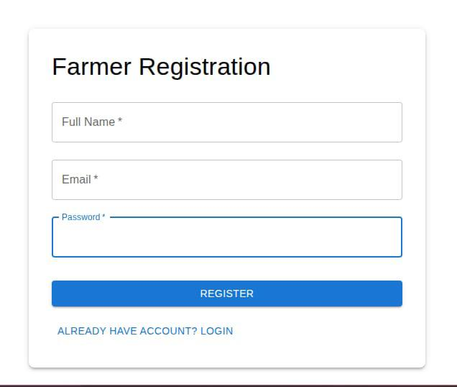
Fig B.1 Login Page

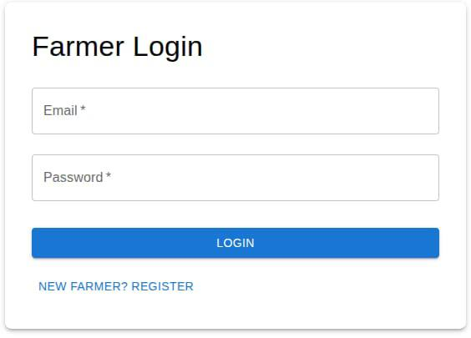
Fig B.2 Farmer Login Page

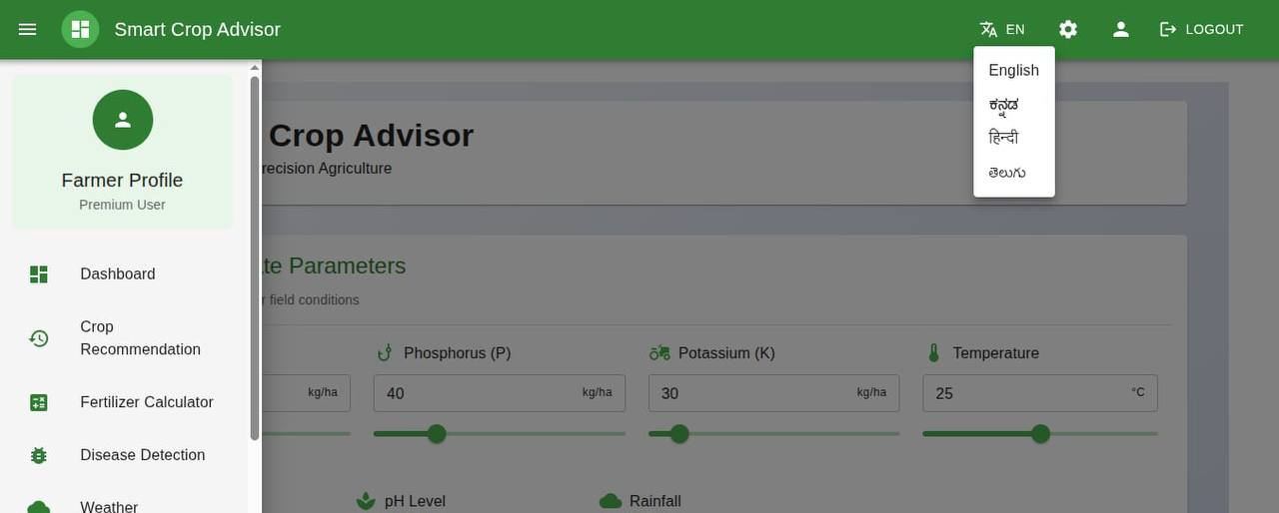
Fig B.3 Dashboard

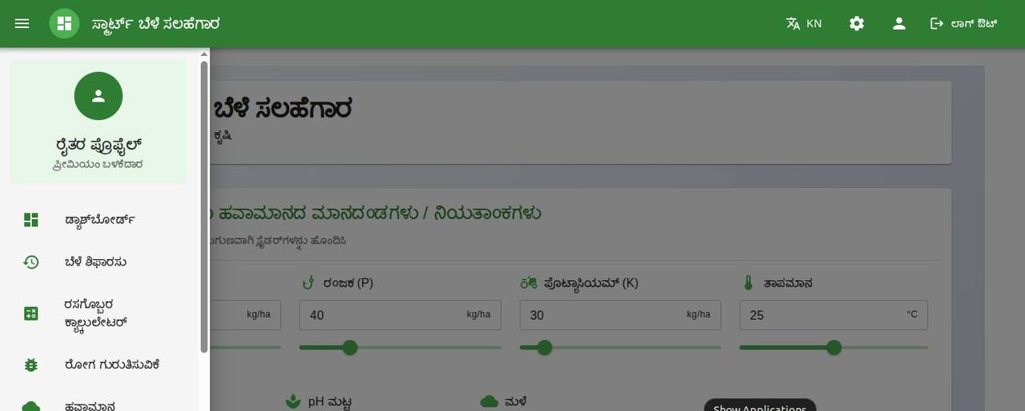
Fig B.4 Admin Video Lectures

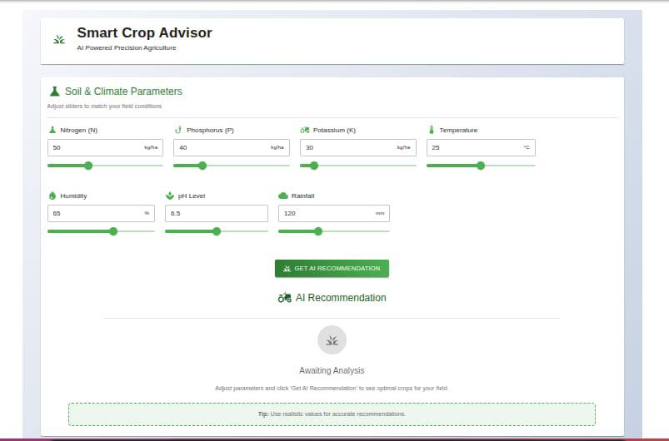
Fig B.5 Parental Report

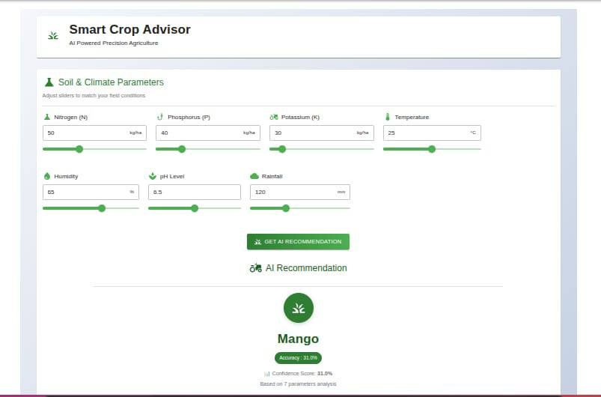
Fig

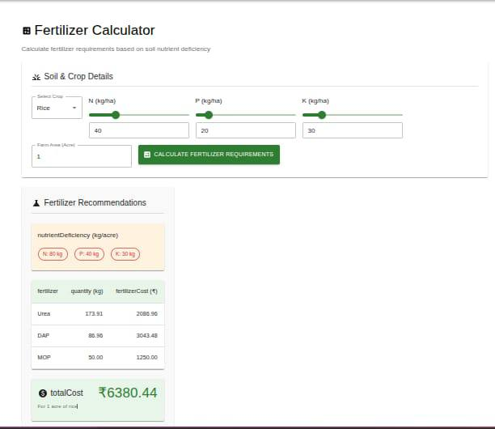

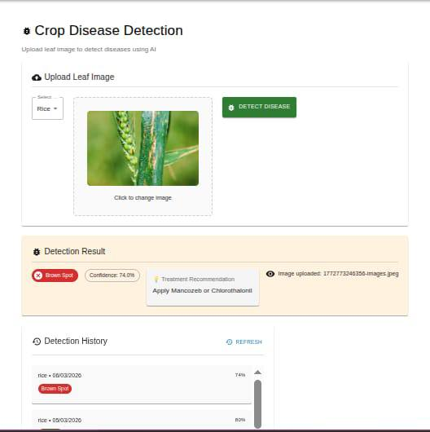
Fig
Fig

Appendix C : Code Snippets
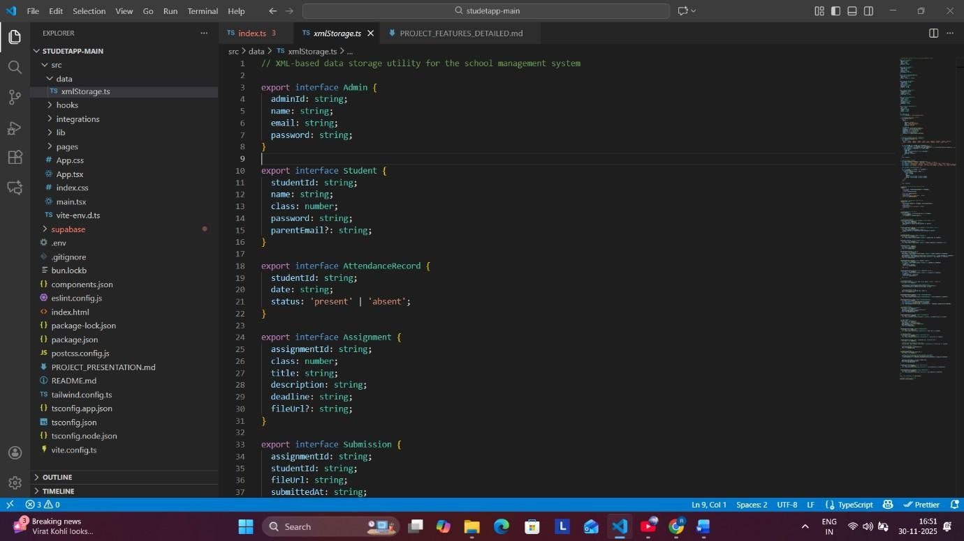
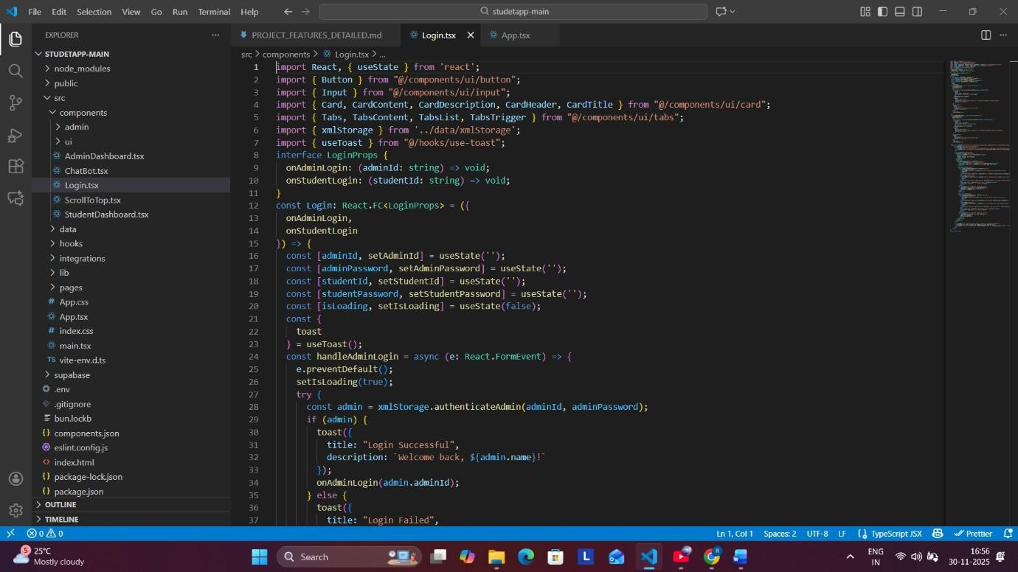
Fig C.1 XML Storage Layer (Data Persistence System)

Fig
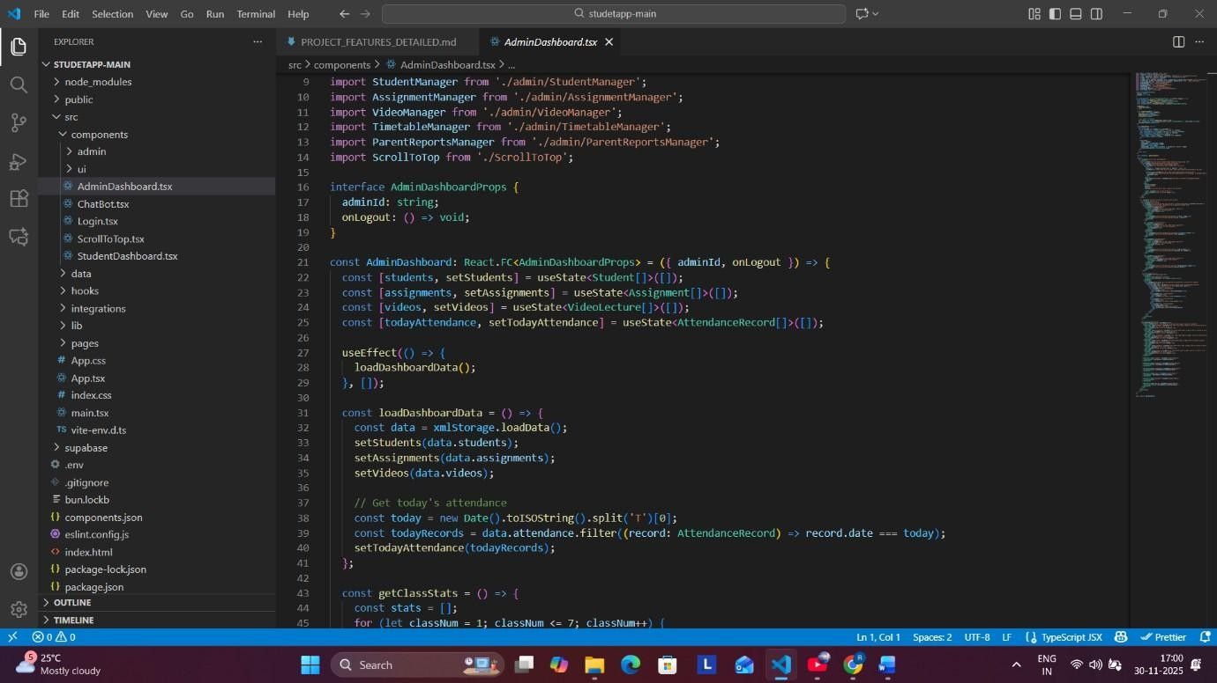
Fig C.3 Admin Dashboard Code (Management Hub)

Appendix D : GitHub Repository
GitHub Link : https://github.com/AMOGM2004/4TH_YEAR_PROJECT
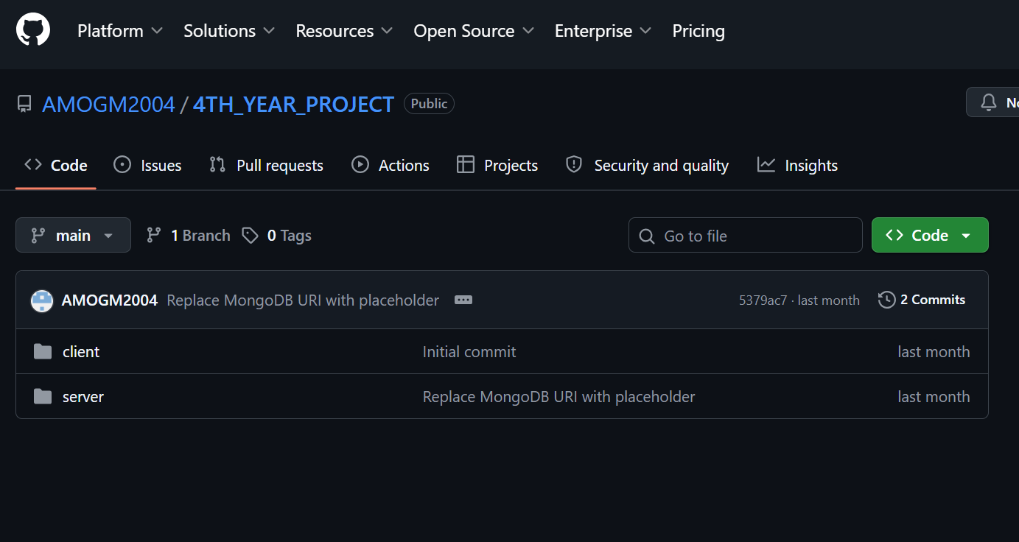
Fig D.1 GitHub Repository

Appendix E : Similarity And AI Report
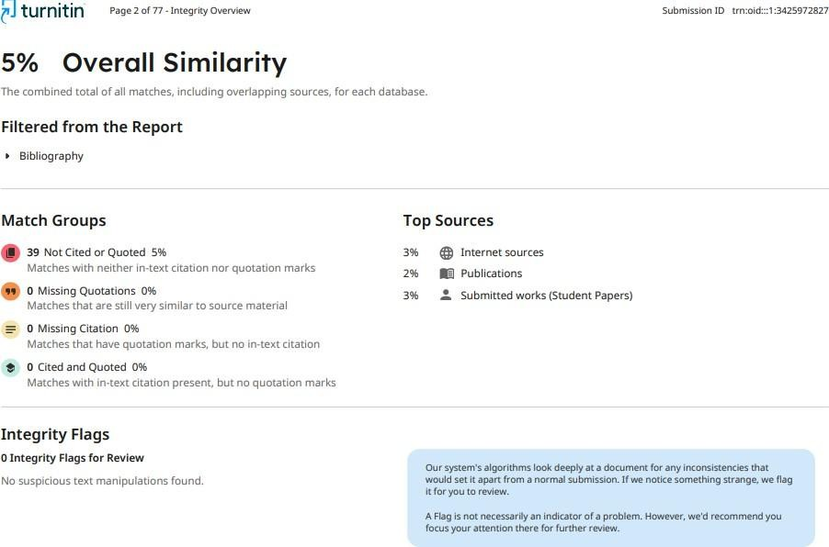
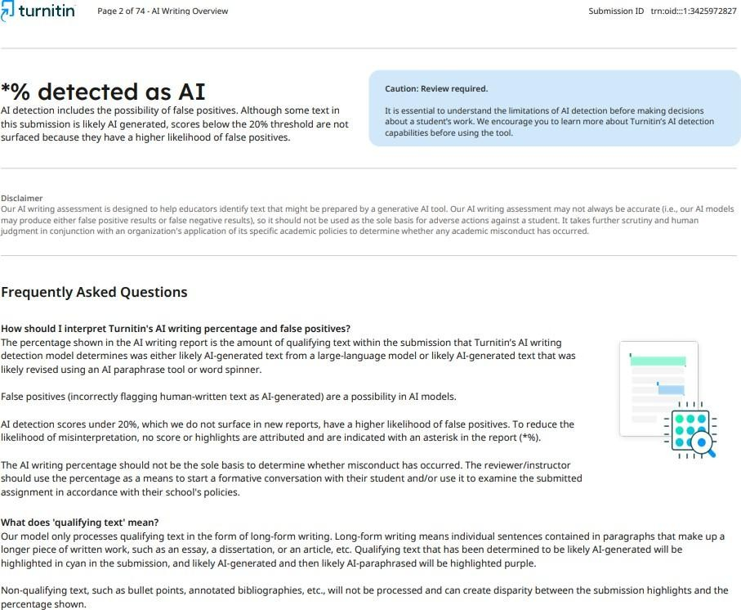
Fig E.1 : Report Similarity

Fig E.2 : AI Report

